FUNERAL PREFERENCE RECOMMENDER SYSTEM: A SMART FUNERAL PLANNING PLATFORM

A Capstone Project
Presented to
The Faculty of
Iloilo Science and Technology University
Miagao Campus
Miagao, Iloilo

In Partial Fulfillment
of the Requirements for the Degree
Bachelor of Science in Information Technology

by

Ressa Mae O. Erfe
Arjun F. Gemalaya
Gian Carlo G. Togiaman

2026

Table of Contents

Title Page .................................................................................................................................... i
Table of Contents........................................................................................................................ ii
List of Tables….......................................................................................................................... iv
List of Figures…………………………………………………………………………………..v
Chapter Page
1 Introduction
Background of the Study……………………………………………...…1
Objectives of the Study……………………………………………..…...3
Conceptual Framework…………………………………………...……..4
Definition of Terms……………………………………………...………5
Significance of the Study……………………………………………..…7
Scope and Limitation of the Study………………………………..……..8
2 Review of Related Literature and Related Studies……………………….…….11
Overview of Funeral Planning Systems………………………………..11
Fundamentals of Personalized Recommender Systems…………….12
Consumer Preferences in the Global Funeral Industry……………..….14
Digital Transformation and Existing Funeral Management Systems ………………..15
Synthesis……………………………………………………………….16
3 Methodology…………………………………………………………………...18
Project Description……………………………………………………..18
Project Development………………………………………...…………19

User Case Diagram……………………………………………………..22
Activity Diagram……………………………………………………….27
Class Diagram………………………………………………………….33
Requirement Analysis………………………………………………….39
System’s Evaluation……………………………………………………44
References ……………………………………………………………..50

List of Tables

Table Page
1 Hardware Specification 39
2 Software Specification 40
3 Technology Stack 41
4 Distribution of Evaluator Participants 45
5 Criteria Used for Evaluation of IT Experts Based on ISO/IEC 25010:2023 46
6 Criteria Used for Evaluation of End Users Based on ISO/IEC 25010:2023 47
7 Criteria Used for Evaluation of Funeral Directors Based on ISO/IEC 25010:2023 48
8 Likert Scale Rating 49

List of Figures

Figure Page
1 Conceptual framework 4
2 Agile Methodology 19
3 Use Case Diagram for System Administrator 23
4 Use Case Diagram for User 24
5 Use Case Diagram for Funeral Director 25
6 Activity Diagram For User 27
7 Activity Diagram For Funeral Director 29
8 Activity Diagram for System Work Flow 31
9 Class Diagram 33
10 Sequence Diagram of User and Funeral Directors Interaction Flow 34
11 Entity-Relationship Diagram (ERD) 37
12 System Architecture 43

Chapter I

INTRODUCTION
Background of the Study

The rapid development of information and communication technology has changed how service sectors manage consumer choices and decision-making processes. In various industries, digital platforms are no longer used only for simple transactions but also for organizing complex personal preferences and providing structured assistance during life-changing events. Recent studies show that digital platforms can support decision-making, service coordination, and user interaction in specialized service sectors (Makararpong et al., 2024; Chan et al., 2025).
In the Philippine setting, digital transformation has become a critical direction for improving community welfare. The Department of Information and Communications Technology (DICT) has emphasized national efforts to strengthen technology integration across service sectors to improve efficiency and accessibility. This suggests that localized industries, including the funeral service sector, are being encouraged to adopt more responsive and technology-enabled systems to assist families during times of need.
In many local communities, bereaved families often face "decision paralysis"—a state of being emotionally overwhelmed while forced to make high-cost financial decisions in a very short timeframe. Currently, information regarding funeral packages, religious requirements, and pricing is often shared through informal means such as personal referrals or direct inquiries. While these methods exist, they are often unstructured, inefficient, and difficult to compare. Because of this, families may experience difficulty in finding services that fit
their specific budget and religious preferences.
Related studies support the value of digital platforms for this purpose. Crawford and Holaway (2020) highlighted emerging trends and market responses in the final disposition industry, noting the shift toward personalized digital arrangements. Makararpong et al. (2024) explored the intention to use online platforms for funeral services, while Chan et al. (2025) discussed the effectiveness of funeral support services for socio-economically deprived populations. These studies suggest that digital platforms can improve transparency and coordination. Furthermore, Oubalahcen et al. (2023) explained that recommender systems can improve personalization and support user decision-making in digital environments. Although the present study focuses on localized logic, this literature supports the value of a recommendation feature to make service matching more efficient.
Despite these developments, there is still a lack of a centralized and organized system specifically designed for funeral preference matching among local service providers and bereaved families. The absence of such a platform may lead to wasteful spending, added emotional stress, and limited visibility for local Small-to-Medium Enterprises (SMEs). Without a structured digital system, it remains difficult for families to honor final wishes within their practical means.
To address this gap, this study proposes a Funeral Preference Recommender System: A Smart Funeral Planning Platform. The proposed system aims to provide a centralized digital platform where users can receive relevant provider recommendations based on budget, religion, and location. It includes a sensitive user interface, provider management support, and a matching engine designed to reduce the burden on bereaved families. Through these features, the study seeks to improve accessibility and promote better utilization of local funeral resources.
Objectives of the Study
The study seeks to address the systemic logistical inefficiencies and emotional burdens inherent in traditional funeral arrangements through the implementation of an intelligent digital interface (Victorio et al., 2025). The main objective of this study is to develop the "Funeral Preference Recommender System: A Smart Funeral Planning Platform," a multiplatform application that leverages machine learning to optimize the selection of funeral services for bereaved families.
Specifically, this study aims to;
- identify the user preferences like budget, religion, location, and package preference that influence funeral service selection;
- utilize a recommendation algorithm that matches user preferences with available funeral packages;
- create a centralized database of funeral service providers and their respective package;
- develop a user-friendly interface that simplifies the decision-making process for grieving users; and
- evaluate the system using ISO/IEC 25010.

Conceptual Framework
The conceptual framework of the study is illustrated in Figure 1 showing the input, process, and output.


User budget: Budget of users
Religion: Catholic, Protestant, Iglesia ni Cristo, etc,.
Location: Guimbal or Miagao
Funeral Packages: User preference
Budget
Religion
Location
Recommendation Algorithm

Hybrid Recommendation Engine

Personalized funeral package recommendations
INPUT
PROCESS
OUTPUT
SYSTEM EVALUATION

Figure 1 illustrates the conceptual framework of the study.

Input: The system’s input phase focuses on capturing essential user data to drive the recommendation engine. Crucial variables include the user budget to ensure arrangements remain within practical financial means and religion, accommodating diverse Filipino traditions such as Catholic, Protestant, or Iglesia. Additionally, users
provide their preferred location, whether for home-based wakes or professional funeral facilities, alongside specific service preferences regarding casket types and interment. Lastly, the service preference which is the package setup like casket, service delivery, documentation, casket, and flowers to ensure inclusions of the recommended package are suited.
Process: The system follows an Agile methodology to continuously develop, evaluate, and refine a Hybrid Recommendation System. The core workflow begins by taking user preference inputs and funeral service metadata, which are fed directly into a dual-layer recommender engine. This engine integrates content-based filtering (matching service attributes to expressed preferences) with collaborative filtering (identifying patterns among similar profiles) to generate personalized recommendations. Through an iterative Agile feedback loop, user interactions with the delivered recommendations are continuously evaluated to optimize algorithmic accuracy across successive development sprints.
Output: The final output consists of personalized funeral package recommendations delivered through a sensitive grieving user interface. These intelligent suggestions serve as a filtering mechanism to help bereaved families find and compare arrangements that are culturally dignified, logistically efficient, and strictly aligned with their unique spiritual, budgetary requirements, and personal preferences.

Definition of Terms
The following terms were defined conceptually and operationally for better understanding of the study:
Database Management. Conceptually, database management refers to the systematic organization, storage, and maintenance of data within a structured digital environment to ensure security and efficient retrieval Karpe et al. (2025). Operationally, this study employs database management through integrated backend services (e.g., Firebase) to store and manage user profiles, service provider listings, and funeral package attributes Victorio et al., (2025).
Funeral Service. A funeral service is conceptually defined as a ritualistic practice
aimed at honoring a deceased individual while providing a platform for collective mourning Ahmad et al., (2025). In this study, the term operationally refers to the specific service packages—including religious customs (e.g., Buddhist, Taoist, Christian), body disposal methods, and logistical arrangements—that providers list and users request through the platform Victorio et al., (2025).
Information Overload. Conceptually, information overload is a state where an individual is overwhelmed by a volume of content that exceeds their processing capacity, resulting in difficulty making decisions Tu et al., (2025). Operationally, it describes the logistical challenge faced by bereaved families in this research who must evaluate numerous unorganized service options during periods of intense emotional distress Victorio et al., (2025).
Machine Learning (ML). Machine learning is a sub-discipline of Artificial Intelligence that utilizes algorithms to enable computers to recognize patterns and improve task performance based on data Oubalahcen et al., (2023). Operationally, machine learning serves as the foundational logic for the recommender engine in this study, analyzing user preferences to suggest tailored service packages Victorio et al., (2025).
Multiplatform Application. A multiplatform application is conceptually defined as software designed to function consistently across various digital environments, such as web browsers and mobile interfaces Victorio et al., (2025). Operationally, this refers to the final output of the research—the Everplan application—developed using frameworks that allow accessibility across different hardware devices Victorio et al., (2025).
Preference. Conceptually, preference refers to an individual's inclination toward specific options over others based on sociocultural beliefs, religious requirements, or economic constraints Ahmad et al., (2025). Operationally, preferences are the primary data
inputs collected by the system, such as a family’s budget and specific spiritual requirements, used to drive personalized results Victorio et al., (2025).
Recommender System. A recommender system is conceptually defined as an intelligent filtering mechanism designed to process large datasets and deliver personalized suggestions based on user behavior Kim et al., (2025). Operationally, it is the intelligent interface proposed in this study that maps user preferences against available provider packages to optimize the selection process Victorio et al., (2025).
User Interface (UI). The user interface is the digital space where human-computer interaction occurs, emphasizing intuitive design to facilitate task completion Kim et al., (2025). Operationally, the UI refers to the frontend screens of the application, such as the homepage and request forms, designed to allow bereaved families to compare funeral services with minimal effort Victorio et al., (2025).
Significance of the Study
This study,"Funeral Preference Recommender System: A Smart Funeral Planning Platform,", is expected to benefit the following:
The Bereaved Families. The system serves as a critical support mechanism for families by reducing the emotional and logistical burdens associated with arranging funeral services during periods of intense distress. By offering a centralized platform to find, compare, and personalize arrangements, the system mitigates information overload and simplifies complex tasks such as booking services and managing payments. Furthermore, the inclusion of transparent pricing and tailored recommendations ensures that families can make informed decisions that honor the spiritual and budgetary requirements of their loved ones.
Funeral Service Providers. This research provides funeral homes and related businesses with a sophisticated marketing and management tool to reach a broader digital audience. The system allows providers to list detailed service packages, thereby increasing business transparency and fostering trust with potential clients. Operationally, the application assists in professionalizing service delivery by automating resource allocation, tracking service requests, and reducing communication errors inherent in manual coordination.
The Information Technology Community. The study offers a technical contribution to the field of software development by demonstrating the application of hybrid recommendation algorithms and machine learning within a niche service sector. It provides practical insights into feature engineering for sensitive datasets, focusing on how to map complex cultural behaviors and personal preferences into predictive models. Additionally, the use of the Agile methodology in this study serves as a reference for developers seeking to build responsive, multidevice systems that require high levels of user interaction and iterative feedback.
Future Researchers. This research serves as a foundational reference for investigators exploring the emerging field of Thanatechnology and the digitization of service-oriented industries Guison-Bautista. The study identifies current gaps in digital funeral management and offers a validated framework for evaluating system acceptability based on ISO 9126-1 standards. Future scholars may build upon this study to explore more advanced AI integrations, such as generative models for memorialization or the long-term impact of digital tools on the grieving process.
Scope and Limitation of the Study
The FPRS functions as a centralized digital platform tailored to streamline funeral coordination in the municipalities of Guimbal and Miagao, serving as an intelligent bridge between bereaved families and local service providers. By utilizing the Responsive Design framework and a Firebase backend, the system offers a responsive interface strictly limited to six core modules: User Registration, User Input (budget, location, religion, service preference), Package Recommendation, Provider Search, and a Feedback System. The system aggregates demographic data, religious customs, and budgetary requirements to generate personalized service recommendations through a hybrid algorithm, allowing families to efficiently compare available packages from a single website.

This implementation is essential for Guimbal and Miagao, where families currently navigate a number of 3 local funeral homes in Guimbal and 1 funeral homes in Miagao through inefficient manual coordination that often leads to scheduling conflicts, miscommunication, and a total lack of online funeral services locally. Because funeral planning involves grieving families, the system is designed with ethical sensitivity and ensuring secure personal data handling to protect families during their period of vulnerability. The platform utilizes a respectful user interface and emotional UX design to simplify complex logistical tasks, accommodating the reduced cognitive load of those in mourning and facilitating the cultural spirit of pakikiramay (communal sympathy).

While the platform optimizes the initial logistical phase of funeral planning, its operational scope is strictly delimited to these core coordination tasks; it does not include booking generation; it does not process legal documentation such as death certificates or wills, nor does it facilitate long-term memorialization. Furthermore, the system currently lacks integrated real-time payment processing, requiring families to finalize financial transactions and specific service
customizations directly with providers. Because the recommender system relies on partner-provided data, it remains susceptible to the "cold-start" challenge for new content and is limited to conventional funeral practices existing within the municipalities, excluding specialized alternatives like eco-funerals or "cryomation".
CHAPTER II

REVIEW OF RELATED LITERATURE AND RELATED STUDIES

The rapid development of information and communication technology has fundamentally transformed how service sectors manage consumer choices and decision-making processes. Digital platforms are no longer confined to simple transactions; they now organize complex personal preferences and provide structured assistance even during some of life's most difficult moments (Kondraguntla & Kumaran, 2026; Tu, 2025). This evolution extends to the funeral service industry, where traditional regimes are increasingly reimagined through digital architectures that prioritize efficiency, transparency, and cultural sensitivity (Slominski, 2023).

In the Philippine context, funeral planning remains deeply rooted in cultural and religious tradition. Filipino families observe practices such as the lamay or burol the traditional wake wherein communal prayer, music, and shared mourning reflect the collectivist nature of Filipino grief (Montesa, 2024). These practices are profoundly shaped by religious affiliation; Catholic families, for instance, observe the nine-day novena (pasiyam) and the 40th-day prayer as integral rites of mourning (Montesa, 2024; Ellorza et al., 2023). Despite the deeply personal nature of these practices, bereaved families in municipalities like Miagao and Guimbal are often forced to make high-cost, high-stakes decisions within very short timeframes frequently relying on informal referrals and word-of-mouth with no structured platform available to compare local funeral providers and their offerings.

This chapter provides a scholarly review of literature and studies that collectively justify the development of the Funeral Preference Recommender System (FPRS). The FPRS is a web-based platform that accepts user inputs on budget, religious affiliation, and location, and then recommends the most suitable funeral home from among four (4) registered local funeral service providers in Miagao and Guimbal, Iloilo. Rather than facilitating direct booking, the system provides the contact information of the recommended funeral home, allowing the bereaved family to reach out and make arrangements directly. This chapter covers personalized recommender systems, consumer preferences in funeral services, digital transformation in the funeral industry, Filipino mourning behavior, and relevant local and foreign system developments. The chapter concludes with a synthesis that identifies the research gap the FPRS is designed to address.

Fundamentals of Personalized Recommender Systems

Personalized recommendation systems (RS) have become foundational technologies in the digital era, serving as critical filtering mechanisms that mitigate information overload across diverse domains (Kim et al., 2025; Tu, 2025; Lawal, 2023). By delivering suggestions tailored to individual user behavior, preferences, and history, these systems transform service ecosystems from reactive models into assets of predictive intelligence (Kondraguntla & Kumaran, 2026). Early frameworks relied heavily on memory-based collaborative filtering; however, contemporary research documents a clear shift toward hybrid recommendation engines that overcome persistent technical barriers such as data sparsity and the cold-start problem the difficulty of generating accurate recommendations for new users with no prior interaction history (Kim et al., 2025; Tu, 2025).

Content-Based Filtering (CBF) is one of the two primary techniques used in recommender systems. It works by analyzing the attributes of items such as price, category, and specifications and matching them against a user-defined profile. In the context of the FPRS, CBF allows the system to evaluate each of the four registered funeral homes based on explicit user inputs: budget range, religious affiliation, and geographic location. The system then filters and ranks these providers according to how well their available packages match the user's stated preferences (Kim et al., 2025). Collaborative Filtering (CF), on the other hand, predicts user preferences based on the behavioral patterns of other users with similar profiles identifying what a user is likely to want based on what similar users have chosen (Lawal, 2023; Tu, 2025). While CF is powerful, it suffers from the cold-start problem in environments with few existing users, making it unreliable as a standalone approach for a newly deployed, localized system.

To resolve these limitations, the hybrid recommendation approach combines both CBF and CF, capitalizing on the strengths of each while compensating for their individual weaknesses (Tu, 2025; Kim et al., 2025). Comparative analysis of state-of-the-art algorithms reveals that while traditional techniques like Matrix Factorization provide a stable baseline, advanced architectures such as Neural Collaborative Filtering and Graph Neural Networks demonstrate superior accuracy in complex, multi-attribute environments (Lawal, 2023). However, despite their predictive power, deep learning-based systems are often criticized for their lack of interpretability — a significant concern in emotionally sensitive domains such as end-of-life planning, where families must trust and understand why a particular funeral home is being recommended to them (Kim et al., 2025; Oubalahcen et al., 2023). The FPRS addresses this by using a hybrid engine that is both accurate and explainable, presenting the recommended funeral home alongside its contact details so that families can make fully informed decisions before reaching out.

Consumer Preferences in the Global Funeral Industry

Consumer decision-making in the funeral industry is uniquely complex due to the emotional state of the decision-maker. Bereaved families must make high-cost financial choices under intense emotional distress and with very limited time — a condition researchers describe as grief-related consumer vulnerability (Victorio et al., 2025; Makararpong et al., 2024). Studies show that in this state, families often experience decision paralysis: an overwhelming inability to evaluate options clearly, which can result in impulsive or uninformed service selections (Makararpong et al., 2024; Ahmad et al., 2025). Having a structured recommendation platform that narrows down choices to the most compatible provider from a curated list significantly reduces this decision burden.

Ahmad et al. (2025) on the Johor Bahru funeral market identified budget, location, and religious compliance as the three primary factors influencing consumer choice of funeral service providers. Similarly, Makararpong et al. (2024) found that in Thailand, the intention to use online funeral platforms is strongly driven by perceived usefulness particularly the ability to compare service packages, pricing, and provider reputations from a single interface. These findings directly support the design logic of the FPRS, which uses these exact three parameters, budget, religion, and location as its primary filtering variables to recommend the most suitable funeral home from among four registered providers in Miagao and Guimbal.( Paiva et al.,2023) further documented that religious beliefs significantly influence end-of-life preferences, including choices between burial and cremation, underscoring the need for religion-specific filtering as a core feature rather than an optional field.

The impact of AI-driven personalization extends beyond technical performance to influence consumer trust and purchase intention. Empirical evidence suggests that personalization significantly increases perceived relevance and reduces the search effort required by users, improving both satisfaction and decision confidence (Kim et al., 2025; Tu, 2025). In the FPRS context, rather than requiring the bereaved family to contact and compare all four funeral providers manually, the system performs this comparison automatically and presents the most suitable match along with the provider's contact information allowing the family to reach out directly and proceed with arrangements at their own pace. This design reflects the balance between technological convenience and human-centered decision-making that researchers identify as critical in emotionally sensitive service domains (Kim et al., 2025).

Additionally, the global funeral industry is witnessing emerging consumer trends including the rise of eco-friendly alternatives such as green burials, which prioritize biodegradable materials and natural decomposition (Slominski, 2023). While currently niche, these preferences indicate that funeral service platforms of the future must be flexible enough to accommodate evolving consumer values alongside established religious and cultural practices. The FPRS accounts for this by designing an extensible preference model that can incorporate additional filtering parameters as local funeral provider offerings and consumer preferences in Miagao and Guimbal continue to evolve.

Filipino Funeral Traditions and Cultural Considerations

Filipino funeral culture is characterized by its deeply communal and religiously governed nature. The lamay or burol the traditional Filipino wake is a multi-day event in which family members, neighbors, and community members gather to pray, share meals, and keep vigil beside the deceased (Montesa, 2024). The wake is not merely a social convention but a structured religious ritual, particularly for Catholic families who incorporate specific prayers such as the rosary, the novena, and the pasiyam — the nine-day prayer observed after burial — as non-negotiable elements of the mourning process (Montesa, 2024; Ellorza et al., 2023). Funeral homes in Miagao and Guimbal must therefore be capable of accommodating these specific religious rites, and any recommendation system operating in this context must treat religious compliance as a foundational matching criterion.

These religious obligations differ significantly across denominations. Catholic and Protestant families share some overlapping practices but diverge on key rituals such as the use of sacraments and the structure of burial rites. Iglesia ni Cristo, one of the largest indigenous Christian denominations in the Philippines, observes distinct funeral conventions that exclude certain Catholic rites entirely (Montesa, 2024). This diversity underscores the necessity of religion-specific filtering within the FPRS — enabling the system to match each bereaved family to whichever of the four registered funeral homes is most capable of honoring their specific religious practices. This feature is absent in all comparable foreign systems reviewed in this chapter.

Financial considerations are also deeply embedded in Filipino funeral culture. Families often rely on abuloy communal financial contributions from relatives, neighbors, and community members to offset the high cost of funeral packages (Montesa, 2024; Victorio et al., 2025). Despite this communal safety net, funeral expenses remain a significant burden, particularly for low-income families in rural municipalities like Miagao and Guimbal. The need for budget transparency and the ability to identify a provider whose packages fall within the family's financial capacity is therefore not merely a matter of consumer convenience but a practical necessity. The FPRS directly addresses this by incorporating budget as a primary filtering variable alongside religion and location, ensuring that the recommended funeral home is both financially and culturally appropriate for the family.

Filipino Grief and Digital Mourning Behavior

Digital platforms have become significant spaces for Filipino mourning practices, particularly following the COVID-19 pandemic, which restricted physical attendance at wakes and funerals and accelerated the adoption of virtual mourning tools. Studies by Kenneth and Namoco (2025) and Kenneth and Teresa (2025) document how Filipino families use Facebook as a digital bayanihan a virtual extension of the communal support traditionally expressed through physical presence at the lamay. Posts, live streams, and online prayer groups serve as contemporary manifestations of pakikiramay, the Filipino value of shared grief and empathetic solidarity.

Villafuerte et al. (2023) further documented the phenomenology of social media mourning among Filipino millennials, finding that digital memorialization through online platforms fulfills a psychological need for continuing bonds with the deceased — a concept supported by bereavement theory. MacNeil et al. (2021) similarly found that virtual funerals conducted during the pandemic, while not fully replacing physical rites, provided meaningful alternatives for geographically dispersed family members. Together, these studies confirm that Filipino communities are ready to adopt digital tools in the context of death and funeral planning, a foundational assumption that supports the cultural acceptability of the FPRS as a digital aid for bereaved families navigating the process of selecting a funeral service provider.

Digital Transformation and Existing Funeral Management Systems

The digital transformation of the funeral industry sometimes referred to as thanatechnology has progressed from simple informational websites to sophisticated service management platforms (Kuznetsova, 2021). Kuznetsova (2021) documented that the digitalization of funeral services improves industry transparency, reduces logistical costs, and enables remote coordination — benefits that are especially significant for families managing arrangements across geographic distances. Crawford and Holaway (2020) further noted a global industry shift toward personalized digital arrangements, driven by changing consumer expectations for convenience and service customization.

Several existing digital systems have attempted to address operational challenges in funeral service management. Everplan, developed by Victorio et al. (2025), is a multiplatform funeral arrangement and management system that allows users to browse funeral packages and contact providers. The Funeral Management System proposed by Karpe et al. (2026) focuses on administrative efficiency automating vehicle booking, staff scheduling, and financial reporting for funeral home operators. While these tools represent meaningful progress in funeral service digitalization, both are limited in a critical way: neither incorporates an intelligent recommendation engine that actively matches user preferences to the most suitable provider from a set of registered funeral homes. The FPRS is distinct from both in that it does not manage bookings or internal funeral home operations; rather, it serves as a preference-matching bridge accepting the user's inputs on budget, religion, and location, recommending the most compatible funeral home from among four registered providers in Miagao and Guimbal, and then providing that provider's contact information so the family can proceed with direct communication and arrangement.

The following table compares the features and limitations of existing funeral management solutions alongside the proposed FPRS:

Table I
Comparison of Existing and Proposed Funeral Management Systems

System | Key Features | Limitations
Everplan (Victorio et al., 2025) | Funeral package display, provider listings, multiplatform support, direct provider contact | No AI recommendation engine; cannot match users to the most suitable provider based on budget, religion, and location
Funeral Management System (Karpe et al., 2026) | Administrative automation for resource allocation, vehicle booking, staff management, and financial reporting | Primarily an internal operations tool for funeral homes; no user-facing preference matching or provider recommendation feature
Funeral Preference Recommender System (Proposed) | Hybrid recommendation engine matching user inputs (budget, religion, location) to the most suitable funeral home from four registered providers; displays contact information for direct family-to-provider communication | Can registered new funeral providers in Miagao and Guimbal; does not manage bookings or internal operations

Beyond these systems, specialized platforms such as OneRoom and TribuCast have emerged to provide live-streaming services for virtual funerals. However, these solutions address only the remote attendance dimension of funeral services and do not engage with the service selection or provider comparison challenges faced by bereaved families (MacNeil et al., 2021). The FPRS distinguishes itself from all of these systems by functioning as a culturally informed recommendation engine rather than an operational or streaming platform, a role that no comparable local or foreign system currently fulfills within the Philippine municipal context.

Recommender System Applications in Specialized Domains

Recommender systems have been successfully deployed in a growing range of specialized, non-commercial domains beyond their original e-commerce applications. Maulani et al. (2025) developed a web-based recommendation system for academic supervisor allocation in higher education using the C4.5 Decision Tree Algorithm, demonstrating that recommendation logic can be effectively applied to high-stakes, multi-criteria matching problems where a user must be matched to the most suitable option from a defined set of choices. Alsaif et al. (2022) applied matched representation systems to job recommendation, highlighting how content-based matching of user qualifications to item attributes can produce high-precision results in professional service contexts. Tu (2025) reviewed the application of recommender systems in e-learning environments, documenting how hybrid approaches outperform single-method systems in delivering relevant content to learners with diverse profiles.

The parallel between these specialized applications and the FPRS is direct: just as a supervisor recommendation system matches a student to the most suitable thesis adviser from a defined pool of faculty, the FPRS matches a bereaved family to the most suitable funeral home from among four registered providers based on three clearly defined preference parameters. These studies collectively confirm that recommendation systems are effective in domains where decisions carry meaningful real-world consequences and where the user benefits from having a structured system narrow down their choices from a finite set of options (Tu, 2025; Alsaif et al., 2022; Maulani et al., 2025). None of the reviewed studies, however, apply recommender logic to the funeral service domain — confirming the novelty of the FPRS as the first system to bridge this gap in the Philippine municipal context.

Synthesis

The reviewed literature collectively reveals a significant and actionable research gap. Existing studies confirm that recommender systems are effective tools for reducing information overload and facilitating personalized decision-making across a wide range of domains (Kim et al., 2025; Tu, 2025; Lawal, 2023). The global funeral industry is also undergoing meaningful digital transformation, with emerging platforms like Everplan and the Funeral Management System of Karpe et al. demonstrating that technology can reduce logistical burdens and improve coordination between families and providers (Victorio et al., 2025; Karpe et al., 2026; Kuznetsova, 2021). Filipino communities have furthermore demonstrated both the cultural readiness and the practical need for digital tools in the context of death and bereavement, as evidenced by the widespread adoption of social media mourning platforms and the identified pain points of bereaved families in Miagao and Guimbal who currently rely on informal referrals and direct inquiries when searching for funeral service providers (Cabañero & Namoco (2025), 2025; Montesa, 2024).

However, a critical gap persists: no existing system local or foreign provides an intelligent preference-matching platform that recommends the most suitable funeral home to a bereaved family based on the combined parameters of budget, religious affiliation, and geographic location, within a Philippine municipal context. Foreign funeral platforms do not account for the religious diversity and communal financial practices unique to Philippine communities (Makararpong et al., 2024; Karpe et al., 2026). Local systems like Everplan address operational management but lack recommendation logic (Victorio et al., 2025). Recommender systems reviewed in the literature are applied to e-commerce, education, and job matching — but never to funeral services (Tu, 2025; Alsaif et al., 2022; Maulani et al., 2025).

The Funeral Preference Recommender System directly bridges this gap. By deploying a hybrid recommendation engine combining Content-Based Filtering for explicit preference matching and Collaborative Filtering for pattern-based prediction within a PHP and MySQL/Firebase technical architecture, the FPRS evaluates four registered funeral service providers in Miagao and Guimbal and recommends the most compatible one based on the bereaved family's stated budget, religious affiliation, and location. The system does not process bookings; instead, it presents the recommended funeral home's contact information, empowering the family to initiate direct communication and proceed with arrangements in a manner that respects both their grief and their autonomy. It is the first system of its kind to treat religion, budget, and location not as optional fields but as core algorithmic variables within a localized Philippine funeral service context reflecting the actual lived decision-making priorities of Filipino families during bereavement and advancing the practical goal of dignified, accessible, and compassionate funeral planning .

Chapter III
METHODOLOGY
This chapter presents the methodology employed in developing the "Funeral Preference Recommender System: A Smart Funeral Planning Platform" (FPRS). It details the project’s technical characteristics, the specific phases of the development cycle, and the analytical tools used to define system requirements.
Project Description
The Funeral Preference Recommender System (FPRS) is a digital solution designed to streamline the complex process of funeral coordination for families in Guimbal and Miagao. The system addresses the "information overload" often encountered during bereavement by providing a centralized platform for service matching. Traditionally, funeral planning involves significant logistical burdens, which digitalization aims to mitigate by increasing industry transparency and reducing costs (Kuznetsova, 2021).
The platform’s core functionality is powered by a hybrid recommendation engine. This engine integrates content-based filtering, which matches user-defined attributes such as budget, religion (e.g., Catholic, Protestant, Iglesia ni Cristo), and location with available service package. It simultaneously leverages collaborative filtering to predict preferences based on broader user patterns, a strategy that combines the strengths of multiple recommendation techniques to achieve higher accuracy and diversity in results (Tu, 2025). This personalized approach is essential for delivering tailored content that aligns with individual behaviors and cultural requirements (Kim et al., 2025).

Project Development
Project Development
The researchers adopted the Agile methodology for the development of this project (Victorio et al., 2025). This approach prioritizes iterative prototyping and continuous user feedback over rigid, long-cycle planning (Victorio et al., 2025). Agile is particularly suitable for the FPRS as it allows the system to adapt to the complex cultural behaviors and sensitive data handling required for funeral management tools (Karpe et al., 2026).
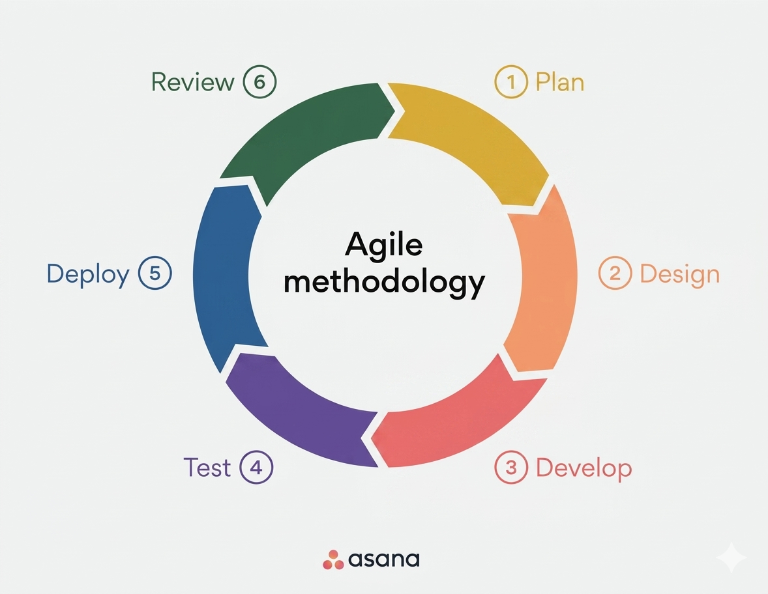
Figure 2: Agile Methodology
Note: Adapted from Agile methodology in system development, by Victorio et al., 2025.

Requirements Phase
The requirements phase identifies the fundamental logistical and financial burdens families face, such as limited service visibility and the high costs associated with funeral packages (Kuznetsova, 2021). Grounded in the study of consumer preferences, the system must prioritize data points including user budget, religion, and location to ensure service suggestions honor specific ritualistic practices such as Catholic or Buddhist customs (Ahmad et al., 2025; Makararpong et al., 2024). Functional requirements emphasize the need for an "intelligent bridge" that allows families to find, compare, and personalize arrangements through a single platform, effectively mitigating "information overload" during high-stress periods (Victorio et al., 2025; Tu, 2025).
Design Phase
The design phase involved analyzing gathered requirements and reports from target users to establish the system architecture, database model, user roles, and user interface (UI). These designs were developed iteratively using the Agile methodology, which facilitates continuous refinement and improvement through iterative prototype cycles and constant user feedback (Victorio et al., 2025; Karpe et al., 2026). This iterative process is essential to verify that the system’s intelligent filtering mechanism effectively addresses the "information overload" and "grief-related consumer vulnerability" common in end-of-life planning (Kondraguntla & Kumaran, 2026; Tu, 2025).
In this phase, the researchers designed wireframes and mockups for the user interface, prioritizing a sensitive grieving UI/UX that emphasizes simplicity, accessibility, and a "single window" interaction model for individuals in deep mourning (Cabañero & Guison-Bautista, 2025; Victorio et al., 2025). The system architecture was designed as a multidevice website, integrating a Tailwind frontend for consistent performance across web and mobile devices, a PHP backend for robust business logic, and a dual-database model combining MySQL for structured records with Firebase for real-time data handling (Maulani et
al., 2025; Karpe et al., 2026). The design process also included defining the Hybrid Recommendation Engine and API structures to ensure seamless communication between the user's preference inputs such as budget, religion, location, and service preference and the centralized database of service providers (Kim et al., 2025; Tu, 2025).
Development Phase
During the development phase, the technical stack is implemented using the Tailwind for the frontend and PHP for the backend logic (Maulani et al., 2025; Victorio et al., 2025). The system integrates a Hybrid Recommendation Engine that combines Content-Based Filtering with Collaborative Filtering to match heterogeneous user attributes against funeral package metadata (Kim et al., 2025; Tu, 2025). Database management utilizes MySQL for structured records of listings and Firebase for real-time data handling, ensuring the system can overcome technical barriers like the "cold-start" problem where historical interaction data is missing (Karpe et al., 2026; Tu, 2025).
Testing Phase
The testing phase evaluates the system against ISO 9126-1 standards, specifically measuring technical indicators such as functionality, reliability, and usability (Victorio et al., 2025). Standard performance metrics, including Precision, Recall, and Root Mean Square Error (RMSE), are applied to validate the accuracy of the recommendation algorithm in predicting user preferences (Lawal, 2023; Tu, 2025). Researchers conduct User Acceptance Testing (UAT) and apply the Technology Acceptance Model (TAM) to measure perceived usefulness and intention to use among bereaved families and service providers (Makararpong et al., 2024; Victorio et al., 2025).
Deployment Phase
The deployment phase involves hosting the FPRS on secure cloud servers to enable
real-time service coordination and data accessibility (Kuznetsova, 2021). Robust security protocols, including user authentication and encrypted data handling, are implemented to protect personal user data from financial risks and fraud (Karpe et al., 2026; Makararpong et al., 2024). This phase ensures that local funeral homes can manage and promote their listings professionally, while families in municipalities like Miagao and Guimbal can initiate recommendation remotely (Karpe et al., 2026; Victorio et al., 2025).
Feedback/Review Phase
In the review phase, the system undergoes regular evaluation through a Feedback System module to monitor performance and identify stability issues or "information overload" (Victorio et al., 2025; Tu, 2025). Feedback loop mechanisms allow for the bias correction of algorithmic models and the integration of real-time preference updates based on user interaction behavior (Tu, 2025). Future iterations focus on introducing advanced features such as AI-driven chat modules to assist with religious ceremony queries and integrated map services for improved logistical coordination (Makararpong et al., 2024; Victorio et al., 2025).

Use Case Diagram.

A Use Case Diagram is a visual representation that defines the system’s functional requirements by illustrating the interactions between external actors – such as bereaved families, funeral directors, and administrators – and the platform’s core functionalities (Hanapi et al., 2023; Karpe et ala.a, 2026). It serves as a foundational blueprint during the system design phase to document exactly what the system must do from the perspective of its users (Karpe et al., 2026).

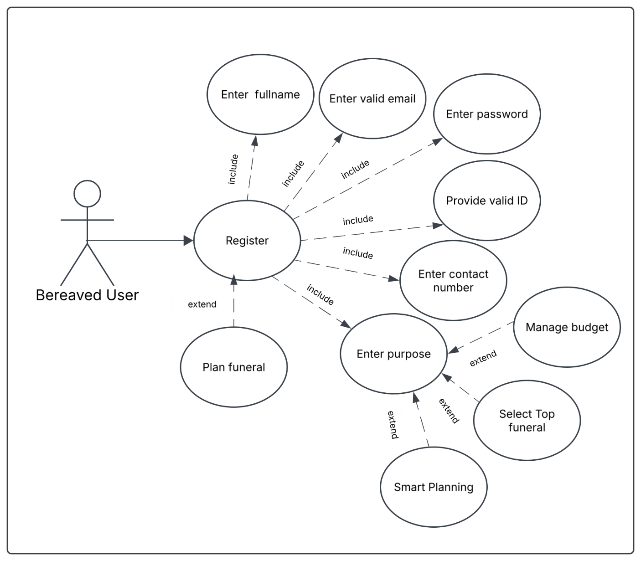
Figure 3 Use Case Diagram for Bereaved Users’ Register

Figure 3. Use Case Diagram for Bereaved Users’ Register
Figure 3 illustrates the Use Case Diagram for the Bereaved User actor within the Funeral Preference Recommender System (FPRS). The workflow begins with the Register use case, which serves as the primary entry point for user onboarding and system access. To complete registration, the system enforces four mandatory sub-processes: Enter fullname, Enter valid email, Enter password, Provide valid ID, and Enter contact number. Following successful registration, the sequence progresses to the Enter purpose use case, which captures the foundational parameters of the user's intent. To accommodate varying user requirements without complicating the main process, secondary functionalities are integrated as optional features. Specifically, the Plan funeral feature provides immediate planning workflows right after registration, while Manage budget, Select Top funeral, and Smart Planning offer optional pathways during the purpose selection stage to supply granular financial and algorithmic criteria. Collectively, these interaction pathways establish a structured, user-centric data collection framework optimized to drive the system’s underlying recommendation model.

Figure 4 Use Case Diagram for Bereaved Users’ Login
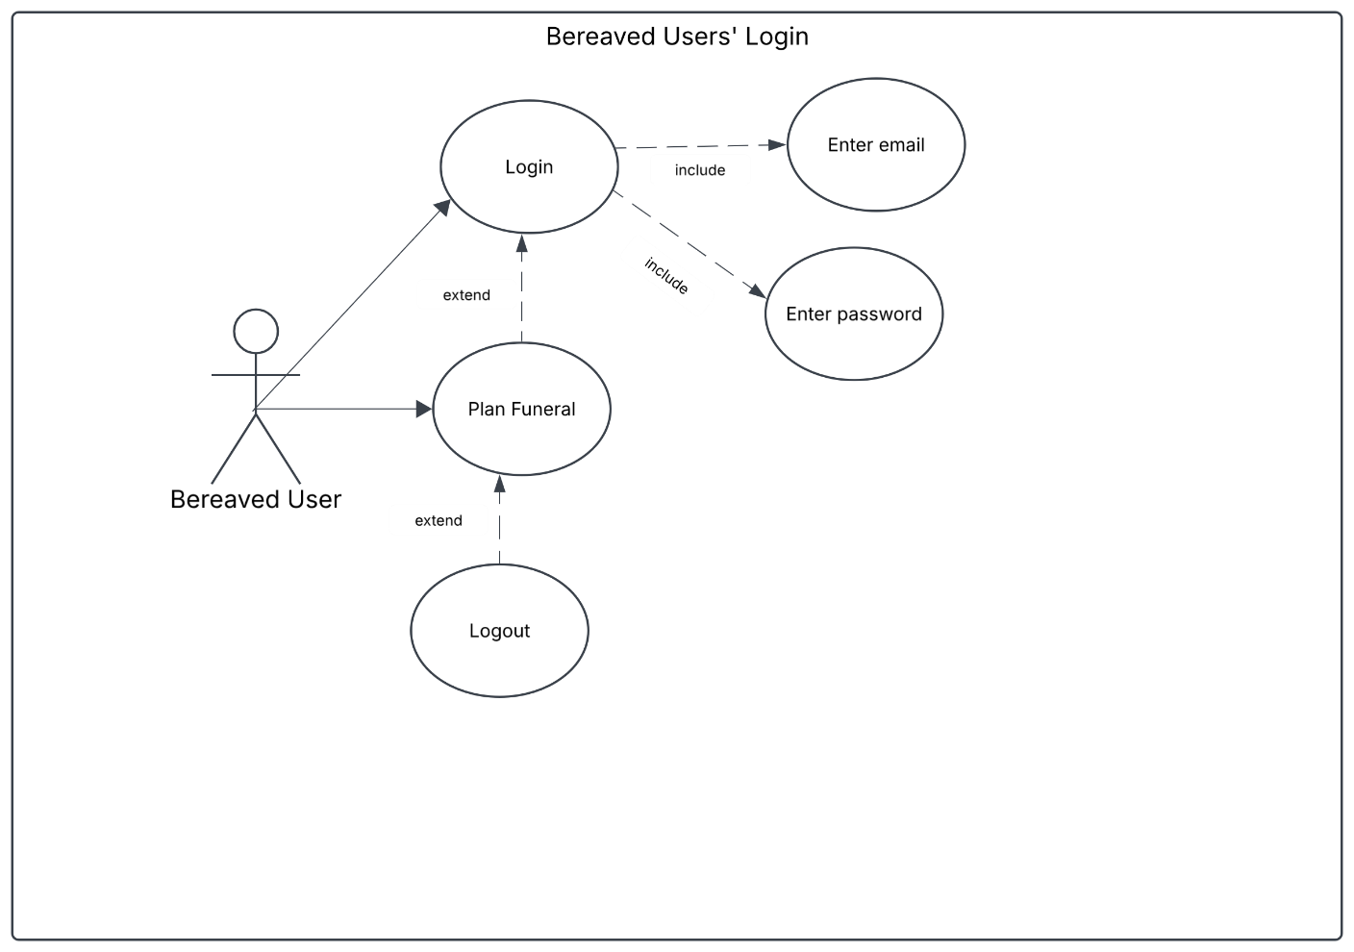
Figure 4 Use Case Diagram for Bereaved Users’ Log in
Figure 4 illustrates the Use Case Diagram for the Bereaved User during the login authentication phase of the Funeral Preference Recommender System (FPRS). The workflow centers on the primary Login use case, which acts as the main gateway for registered users to access system functionalities. To successfully authenticate, the system requires two mandatory inputs: Enter email and Enter password. Beyond basic authentication, the actor can initiate the Plan Funeral use case, which serves as an optional entry point that connects directly to the login process for users seeking immediate planning tasks. Additionally, the Logout feature functions as an optional exit action, allowing users to safely end their active session after navigating through the planning phase. Together, these elements establish a streamlined authentication framework that securely grants access while guiding the user toward essential planning functions.

Figure 5: Use Case Diagram for Directors’ Register

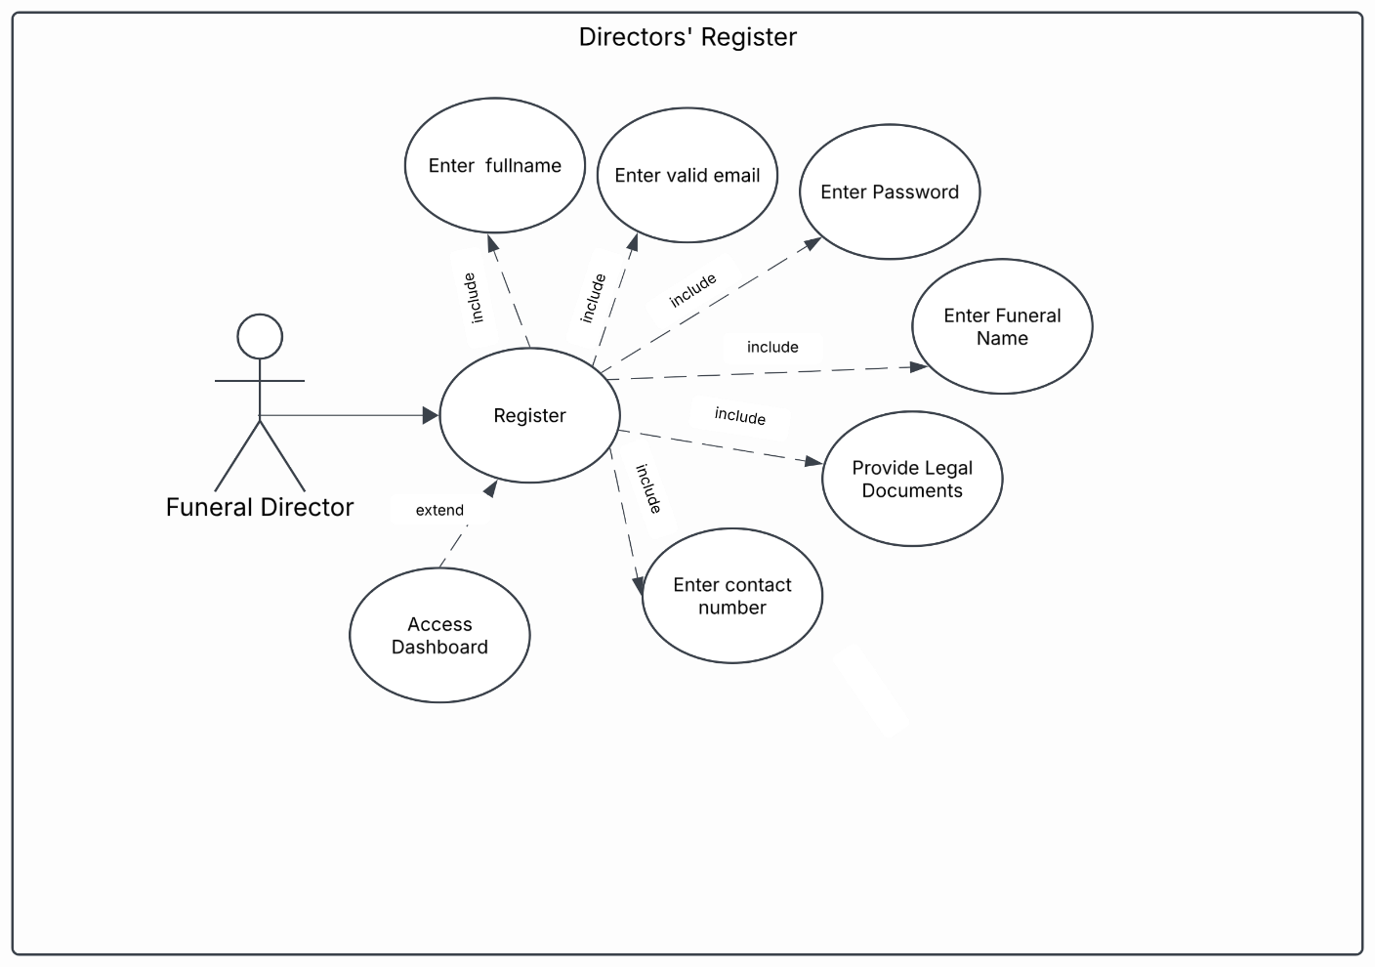

Figure 5: Use Case Diagram for Funeral Directors’ Register
The Use Case Diagram for the Funeral Director actor within the Directors' Register module of the Funeral Preference Recommender System (FPRS). The workflow centers on the primary Register use case, which acts as the mandatory onboarding process for service providers. To complete account setup, the system enforces six essential data inputs: Enter fullname, Enter valid email, Enter Password, Enter Funeral Name, Enter contact number, and Provide Legal Documents.The inclusion of the Provide Legal Documents step serves as a critical verification and compliance layer. This mandates the submission of valid operational credentials such as business permits, sanitary permits, DTI/SEC registration, and official operating licenses to ensure that only legitimate, government-compliant funeral establishments are onboarded onto the platform. Following successful registration and verification, an optional secondary feature, Access Dashboard, allows verified directors to navigate directly to their administrative control panel to manage service profiles and offerings. Together, these functional steps establish an authentic, security-oriented verification pipeline that safeguards user trust and maintains regulatory compliance across the recommender framework.

Figure 6: Use Case Diagram for Funeral Directors’ Login
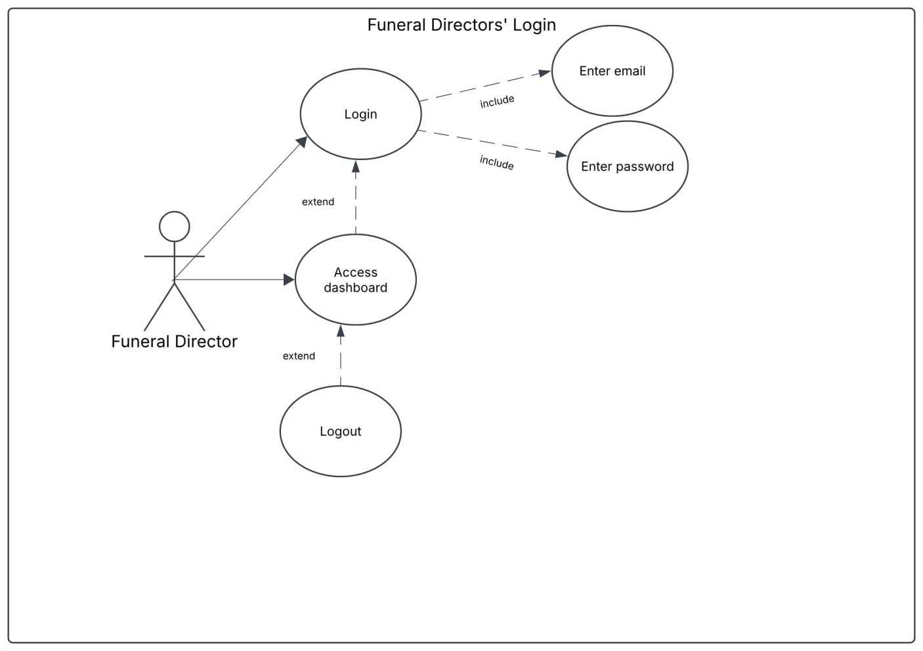
Figure 6: Use Case Diagram for Funeral Directors’ Login\
The Use Case Diagram for the Funeral Director actor during the authentication process within the Funeral Preference Recommender System (FPRS). The core sequence revolves around the primary Login use case, which acts as the official gateway for verified service providers to gain system access. For security and user verification, the process requires two mandatory credentials: Enter email and Enter password. Once authenticated, the director can proceed to Access dashboard, an optional pathway connected directly to the login sequence that grants access to administrative controls where directors can manage service details, update package listings, and review platform interaction metrics. Finally, the Logout action serves as an optional secondary feature, allowing directors to safely terminate their active session after finishing their dashboard activities.
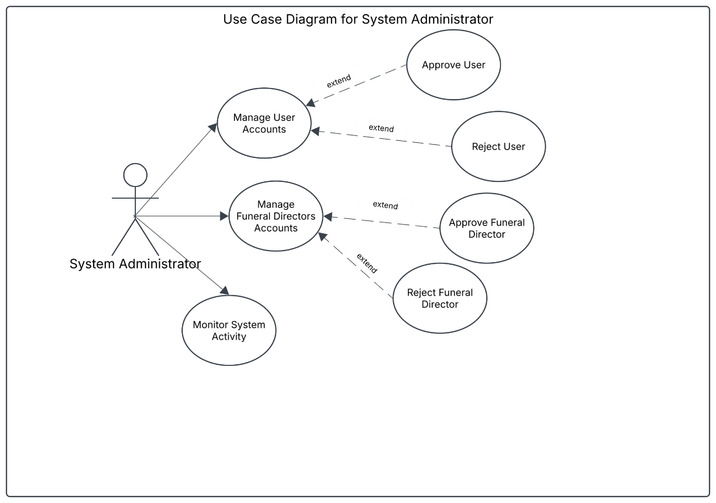
Figure 7: Use Case Diagram for System Administrator

Figure 7: Use Case Diagram for System Administrator
The Use Case Diagram for the System Administrator actor, outlining the high-level administrative oversight within the Funeral Preference Recommender System (FPRS). The workflow centers around three core responsibility areas: Manage User Accounts, Manage Funeral Directors Accounts, and Monitor System Activity. Under Manage User Accounts, the administrator handles platform registration requests from regular users, triggering specific verification choices to either Approve User or Reject User. Similarly, the Manage Funeral Directors Accounts function involves vetting incoming service providers through Approve Funeral Director or Reject Funeral Director, ensuring only legitimate businesses gain access to publish service offerings. Lastly, Monitor System Activity provides continuous platform supervision, allowing the administrator to track active sessions, system logs, and overall operational performance. Together, these processes establish a secure administrative framework that maintains data integrity, controls account access, and safeguards the platform.
Figure 8: Use Case Diagram for Bereaved User
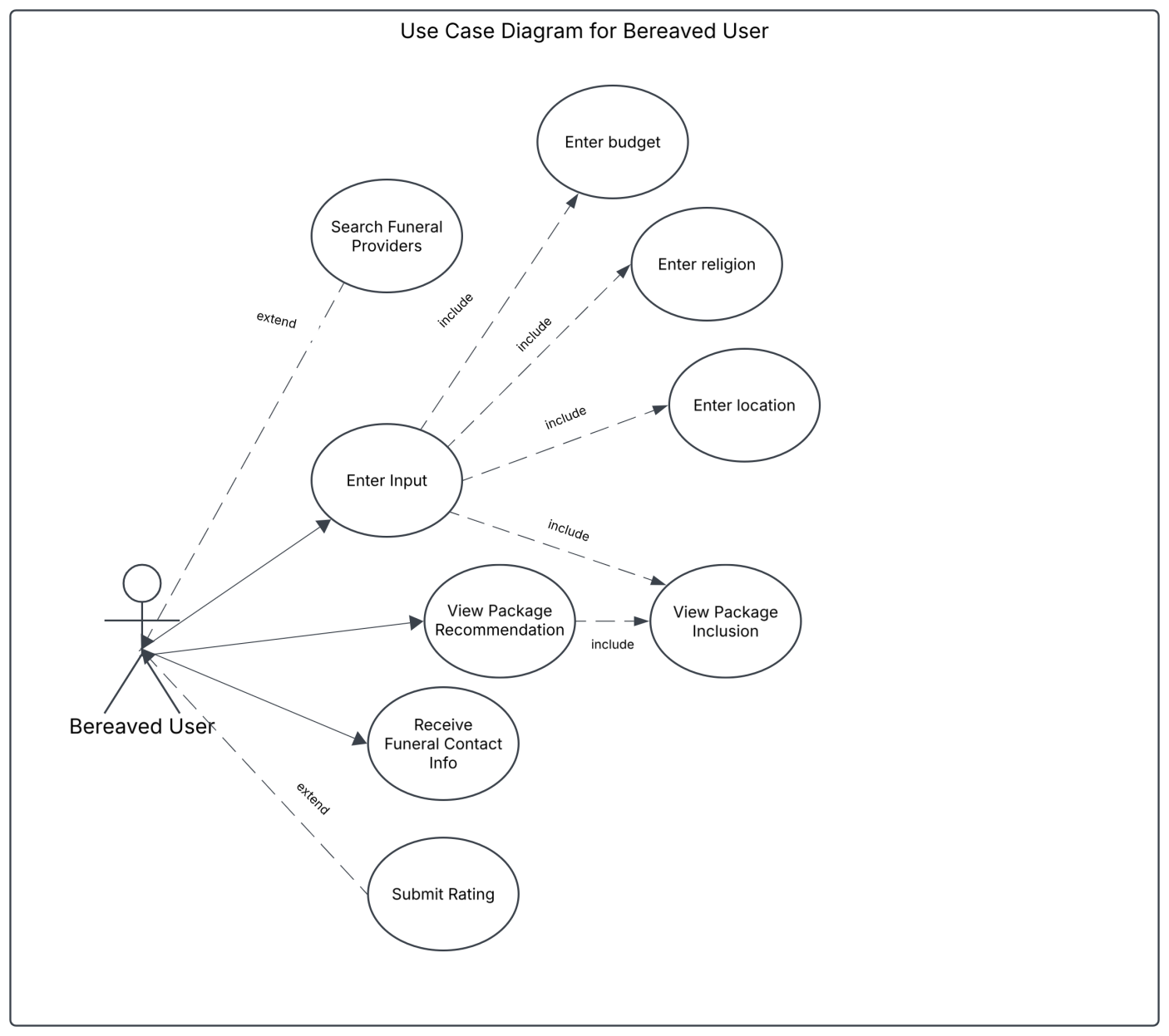

Figure 8: Use Case Diagram for Bereaved User
The Use Case Diagram for the Bereaved User during the recommendation generation and evaluation phase of the Funeral Preference Recommender System (FPRS). The workflow centers around the main interaction node, Enter Input, which captures key criteria to drive the hybrid algorithm through four primary requirements: Enter budget, Enter religion, Enter location, and View Package Inclusion. The inclusion of View Package Inclusion directly as an input requirement serves a critical filtering and customization purpose. Beyond general demographic and financial preferences, specific service components such as casket, documentation, service, floral, and wake arrangement act as functional parameters. If a user is dissatisfied with the specific inclusions of a initially generated suggestion, treating package inclusions as an adjustable input parameter allows them to refine or filter out specific features. This directly recalibrates the recommendation engine to generate alternative packages that better match their exact operational expectations. Once inputs are set, the workflow moves to View Package Recommendation, where the system presents tailored options matching the defined parameters. Additionally, optional pathways allow the user to Search Funeral Providers directly or Submit Rating to give feedback on service relevance. Finally, the sequence completes with Receive Funeral Contact Info, enabling direct coordination with the chosen service provider.

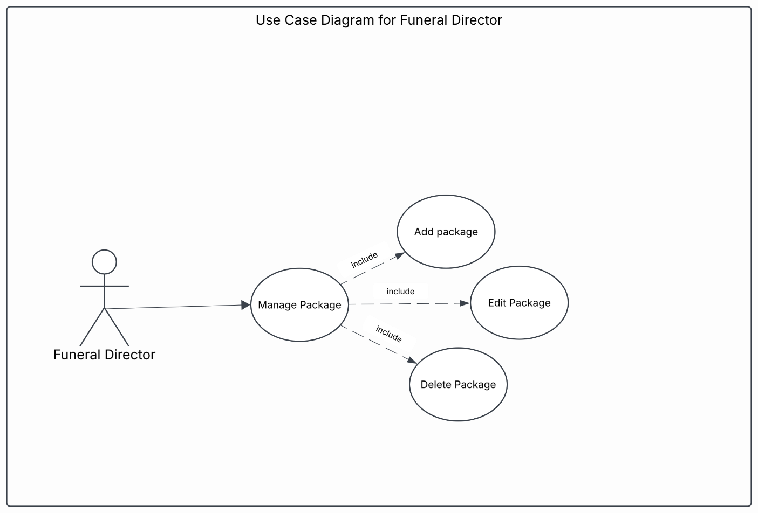
Figure 9: Use Case Diagram for Funeral Director
Figure 9: Use Case Diagram for Funeral Director
The Use Case Diagram for the package management module within the Funeral Preference Recommender System (FPRS). The workflow centers on the main Manage Package use case, which provides centralized administrative control over service offerings. To execute package management, the system incorporates three fundamental sub-processes: Add package, Edit Package, and Delete Package. Through the Add package, new service offerings along with their respective inclusions, pricing, and specific parameters are introduced into the platform data store. The Edit Package action enables real-time updates to existing service details and pricing structures, ensuring recommendation accuracy as offerings evolve. Finally, Delete Package allows for the removal of outdated or discontinued service options.

Activity Diagram
An Activity Diagram within the Unified Modeling Language (UML) serves as a dynamic behavioral blueprint that maps the sequential, parallel, and conditional execution paths of a system’s operations (Karpe et al., 2026). These diagrams will help delineate how multi-user interaction loops, backend algorithmic reasoning, and data synchronization are orchestrated across various user roles (Karpe et al., 2026; Tu, 2025).
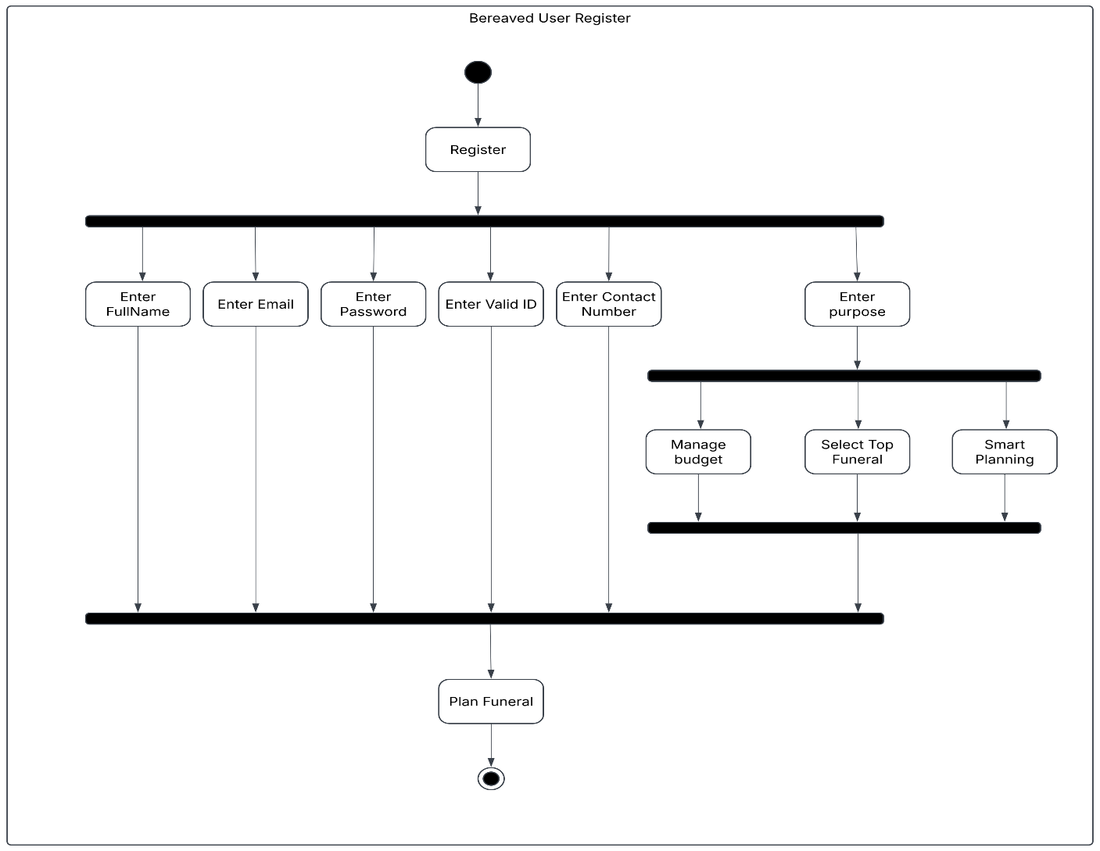
- Activity Diagram For User Register

Figure 10. Activity Diagram for User Register
The activity diagram for user register shows how a user signs up and sets up their account in the Funeral Preference Recommender System (FPRS).Instead of making you do everything one by one, the system lets you fill out your information simultaneously once you hit Register. The top split bar (the fork) splits the process into six paths. Five of those paths are for setting up your account details: entering your FullName, Email, Password, Valid ID, and Contact Number.At the exact same time, the sixth path takes you to Enter purpose to figure out what you need from the system. Right after entering your purpose, that path splits again into three sub-choices so you can fine-tune things: setting your financial limits in Manage budget, picking preferred providers in Select Top Funeral, or using Smart Planning for system recommendations. Once you finish those three options, they merge back together at the middle bar. Finally, all the main paths, your personal details, ID, contact info, and your planning preferences meet up at the bottom join bar. This makes sure the system has all your data locked in before sending you to Plan Funeral and finishing up at the final end node.
b. Activity Diagram For Users’ Login
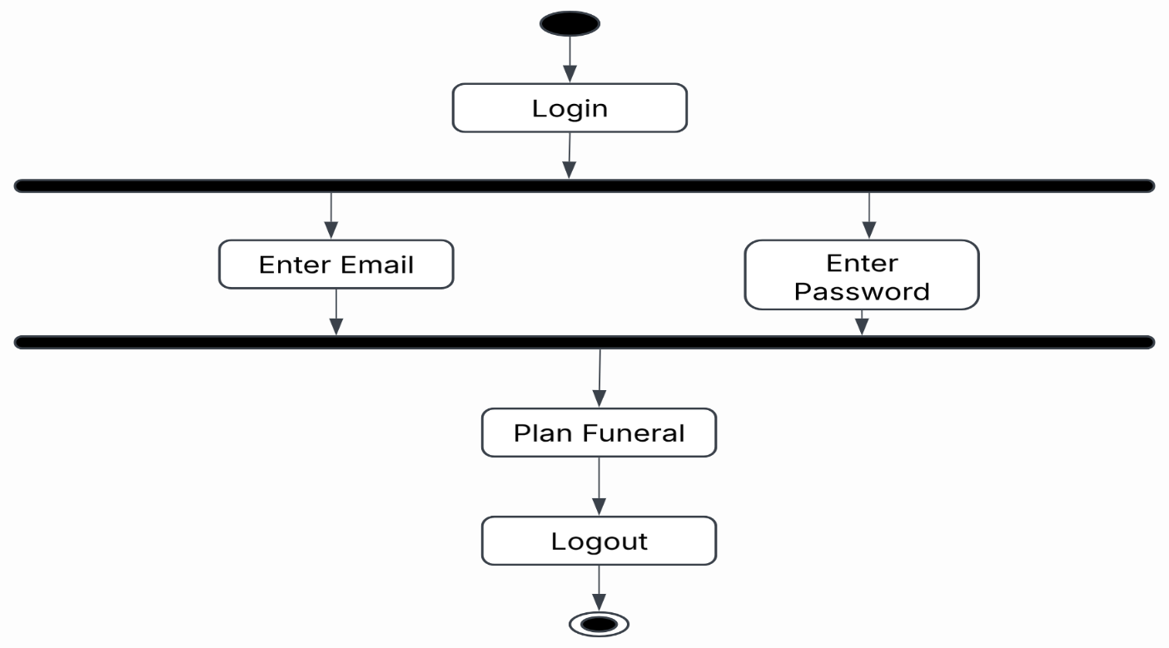
Figure 11. Activity Diagram for Users’ Login
Figure 11 details the Activity Diagram for the authentication and active session workflow of a Bereaved User within the Funeral Preference Recommender System (FPRS). The process begins at the top initial node and leads directly into the Login step to initiate account access. To handle authentication efficiently, the system uses a top horizontal synchronization bar (a fork) to split the process into two simultaneous input tracks: Enter Email and Enter Password. This allows the user to supply both required login credentials in parallel. Once both fields are filled out, the two paths meet at the bottom synchronization bar (a join) to confirm that all required credentials are present before validating the account. After successful login, the system automatically redirects the user to the Plan Funeral module, where they can input specific service parameters, browse recommended packages, and interact with the system's core features. Finally, once the user completes their tasks, the workflow progresses to Logout to safely terminate the active user session and prevent unauthorized access, concluding at the final end node.
d. Activity Diagram for Funeral Director Register
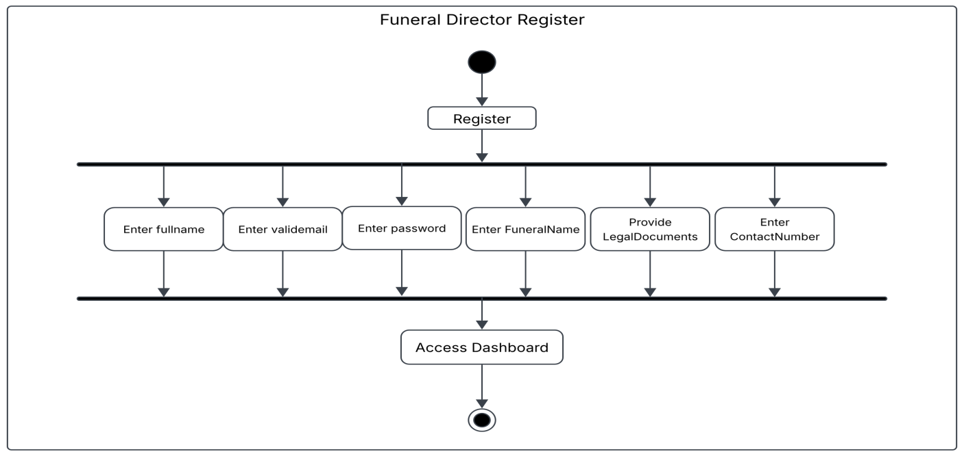
Figure 12: Activity Diagram for Funeral Director Register
The activity diagram illustrates the procedural flow of the registration process for a Funeral Director within the system, detailing the initialization, data input mechanisms, and access granting stages. The process begins at the initial state node, which immediately transitions into the Register activity block. This action triggers a fork node represented by the upper horizontal synchronization bar that splits the single control flow into six concurrent input tasks required for account creation. During this concurrent phase, the user is required to input essential personal and business information. These simultaneous sub-activities include entering the user's full name (Enter fullname), providing a validated email address (Enter validemail), setting an account password (Enter password), supplying the associated business entity's name (Enter FuneralName), uploading necessary verification materials (Provide LegalDocuments), and submitting a telephone contact line (Enter ContactNumber). Because these tasks are bounded by a fork and join bar structure, all six inputs can be processed in parallel or in any order, but all must be completed before the workflow can proceed. Once each of the six input sub-activities is successfully executed, the control flows converge at the lower horizontal synchronization bar, acting as a join node. This ensures that the system validates and verifies the presence of all required information before granting access. Upon synchronization, the process advances to the Access Dashboard activity, where the user is successfully authenticated and directed to the main system interface

e. Activity Diagram for Funeral Director Login
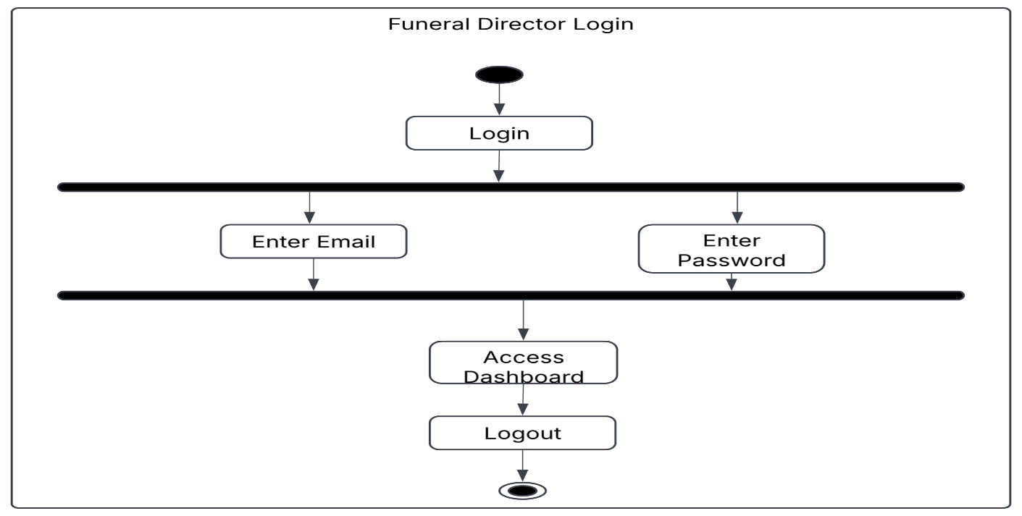

Figure 13: Activity Diagram for Funeral Director Login
Figure 13 illustrates the Activity Diagram for the authentication and session flow of the Funeral Director within the Funeral Preference Recommender System (FPRS). The process begins at the top initial node and moves directly into Login to start administrative access. To ensure a quick login process, the system uses a top horizontal synchronization bar to split the input phase into two concurrent tasks: Enter Email and Enter Password. This lets the director supply both account credentials at the same time. Once both fields are entered, the two parallel paths merge at the lower synchronization bar (a join) to ensure both inputs are provided before authentication occurs. Upon successful credential validation, the system forwards the director to Access Dashboard. Here, the director can perform administrative tasks such as managing service offerings, updating package details, and reviewing user inquiries. Finally, once management tasks are completed, the workflow moves to Logout to safely end the active administrative session, concluding at the final end node.
d. Activity Diagram for User
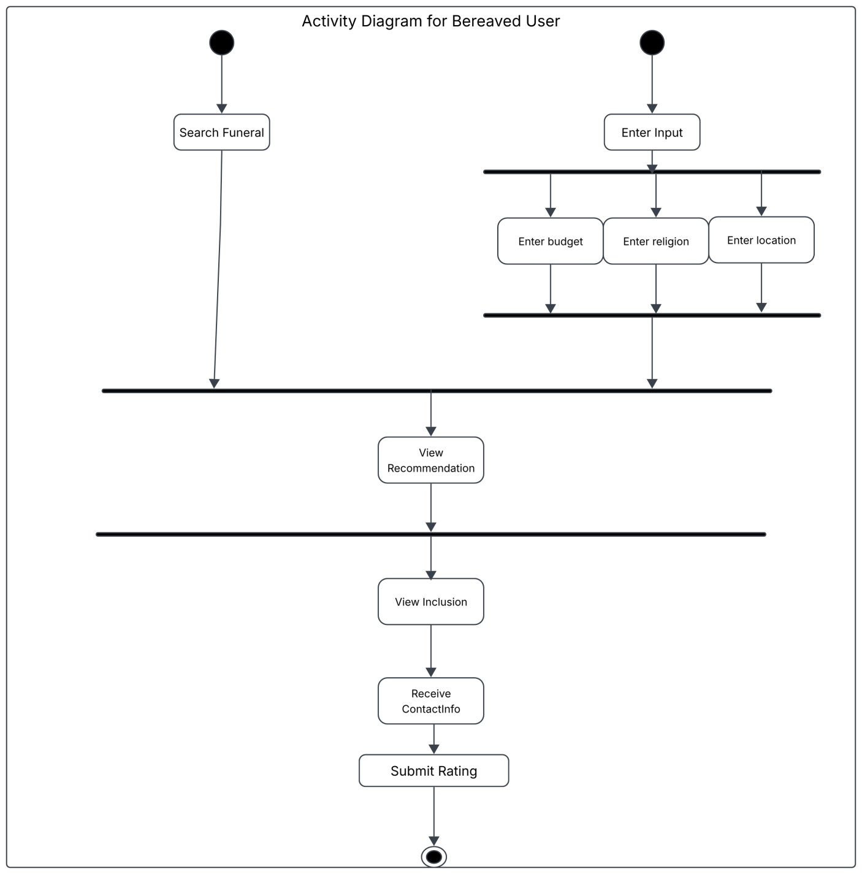
Figure 14: Activity Diagram for User
Figure 14 illustrates the activity diagram for the bereaved user process, detailing how users navigate through searching and filtering funeral options. The workflow begins at two separate initial nodes, allowing two independent paths to initiate the system sequence. The left branch leads directly to the Search Funeral step, representing a general search action. The right branch starts at Enter Input, which splits via a fork node into three concurrent tasks: Enter budget, Enter religion, and Enter location. These three parameters are processed in parallel and must all be completed before converging at a join node immediately following the input phase. After the three input fields are merged, the output of the right branch and the output of the Search Funeral step meet at a central horizontal synchronization line. This ensures that whether a user performs a manual search or submits specific criteria, the system combines these paths to progress to the next stage. Control then flows into View Recommendation, where the system presents tailored options to the user. Following the recommendation view, the process moves through another synchronization line and advances sequentially through View Inclusion, Receive ContactInfo, and Submit Rating. Here, the user reviews package details, retrieves the provider's contact information, and provides feedback on the service. Finally, the entire sequence concludes upon reaching the final state node, marking the end of the user's interaction with the workflow.
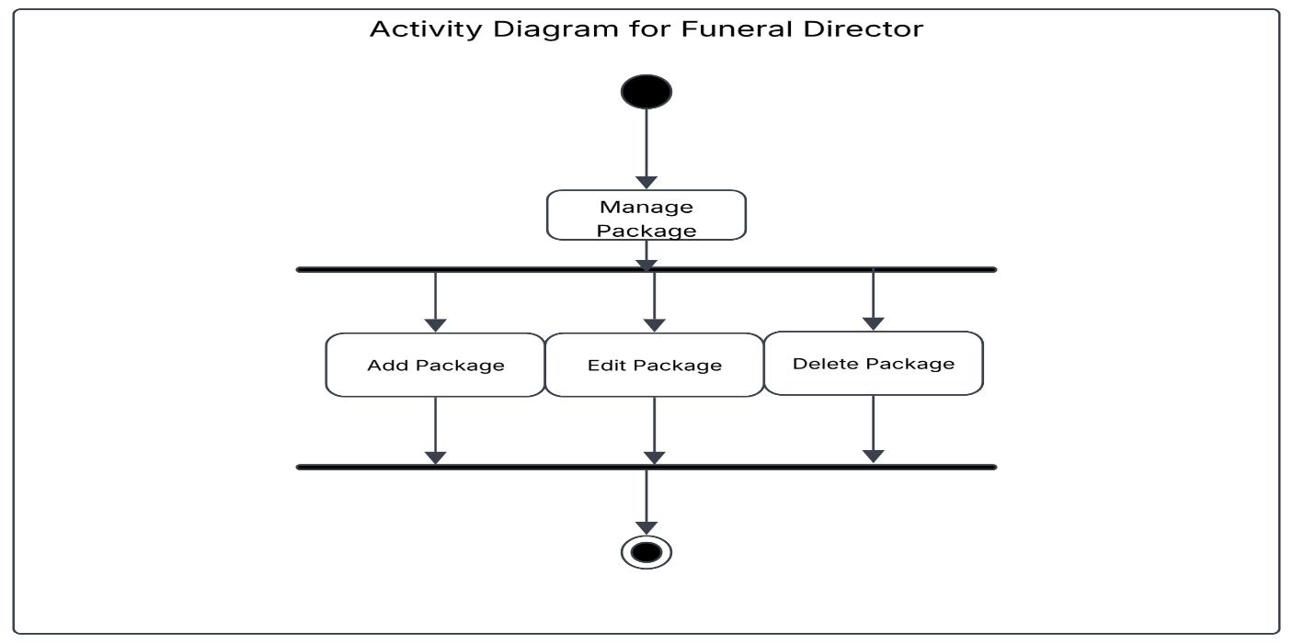
e. Activity Diagram for Funeral Director

Figure 15: Activity Diagram for Funeral Director
Figure 15 illustrates the activity diagram for the funeral director process, detailing how a funeral director manages service packages within the system. The workflow begins at a single initial node, which transitions directly into the main Manage Package action block. Upon initiating package management, the control flow reaches a horizontal synchronization bar that acts as a fork node, splitting the process into three separate management operations. These three available sub-activities—Add Package, Edit Package, and Delete Package—are executed concurrently as part of the package management capability. Once the necessary modifications or package actions are performed, the outgoing flows from all three operations converge at a lower synchronization bar acting as a join node. From this join bar, the control passes directly to the final state node, concluding the overall funeral director package management activity sequence.

Class Diagram
A Class Diagram is a static structure dia gram that describes the structure of a system by showing its classes, attributes, operations (methods), and the relationships among objects.

Figure 16: Class Diagram
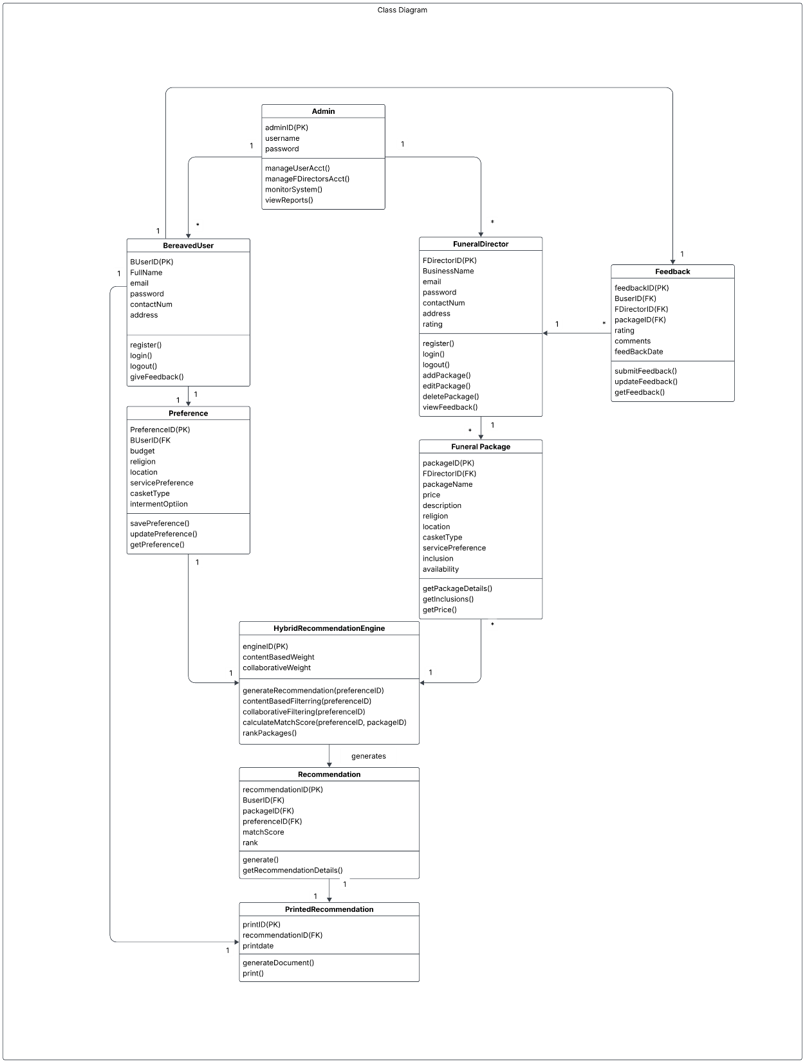
Figure 16: Class Diagram
Figure 16 illustrates the Class Diagram of the Funeral Preference Recommender System (FPRS), presenting the overall object-oriented structure of the proposed web-based recommendation platform. The diagram identifies the major classes, their attributes, methods, and relationships that work together to support the system's primary function of providing personalized funeral package recommendations. Instead of handling online reservations or transactions, the system focuses on matching users with suitable funeral service packages based on their preferences and supplying complete provider information for transactions. At the center of the system is the Hybrid Recommendation Engine, which serves as the core processing component of the application. It receives the preferences submitted by the Bereaved User, including budget, religion, location, service preference, casket type, and interment option. Using these inputs, the engine compares the user's preferences with the available Funeral Packages managed by the Funeral Director. Through the integration of Content-Based Filtering and Collaborative Filtering, the engine calculates a matching score, ranks the available packages, and generates personalized recommendations that best fit the user's needs (Kim et al., 2025; Lawal, 2023). The Bereaved User class represents individuals or families seeking funeral services. This class manages user registration, authentication, and feedback submission. It is associated with the Preference class, which stores the user's funeral-related preferences that serve as the primary basis for generating recommendations. Once the recommendation process is completed, the resulting Recommendation class stores the matched funeral package along with its corresponding ranking and match score. Users may then generate a Printed Recommendation, allowing them to print the recommended package and present it directly to the selected funeral provider during their in-person transaction. On the service provider side, the Funeral Director class is responsible for maintaining the funeral packages available in the system. Each funeral director can create, update, or remove multiple Funeral Package records containing information such as package name, price, location, religious compatibility, inclusions, casket type, and availability. This ensures that the recommendation engine always evaluates updated package information when producing recommendations. To maintain service quality, the system also includes an Admin class, which manages user accounts, funeral director accounts, monitors system activities, and generates reports. Meanwhile, the Feedback class allows bereaved users to evaluate funeral packages and service providers after completing their transactions outside the system. The collected feedback can help funeral directors improve their services while providing additional information for future recommendation processes.

Sequence Diagram
- User and Funeral Directors Interaction Flow
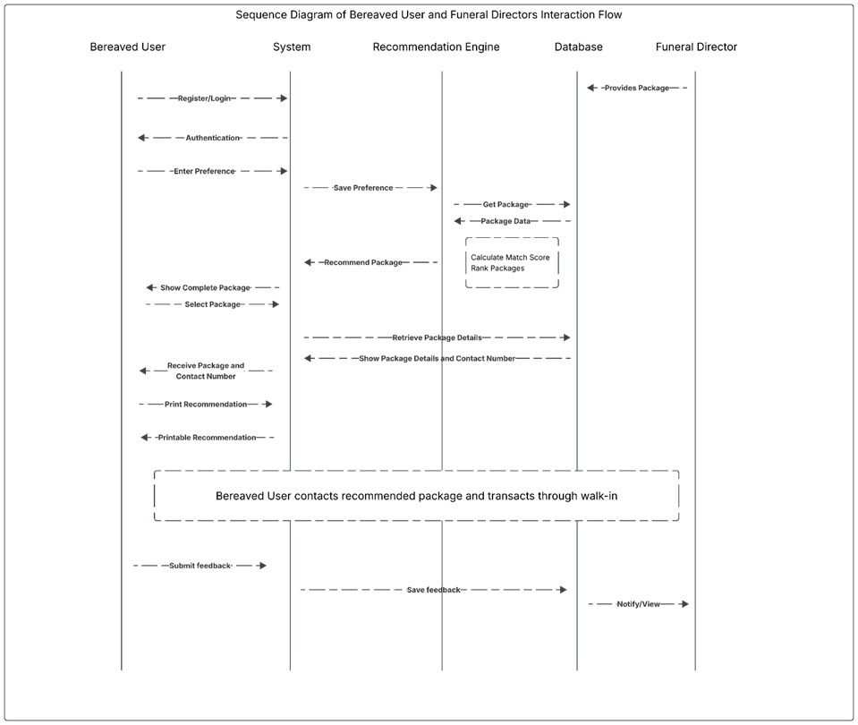
Figure 17 Sequence Diagram of User and Funeral Directors Interaction Flow

Figure 17 Sequence Diagram of User and Funeral Directors Interaction Flow
Figure 17 illustrates the System Interaction Flow of the proposed Funeral Preference Recommender System (FPRS), showing how the Bereaved User, the system, the Hybrid Recommendation Engine, the database, and the Funeral Director interact to provide personalized funeral package recommendations. The sequence begins when the Bereaved User registers or logs into the system. Once the user's credentials are authenticated, they can access the platform and enter their funeral preferences, such as budget, religion, location, preferred services, casket type, and interment option. These preferences are then stored by the system and forwarded to the Hybrid Recommendation Engine for processing. After receiving the user's preferences, the recommendation engine retrieves the available funeral package information from the database. These packages are maintained by the Funeral Director, who regularly updates the system by adding or modifying package details to ensure that the available information remains accurate and up to date. The recommendation engine then compares the user's preferences with the stored package information using the combined approaches of Content-Based Filtering and Collaborative Filtering. Through this process, the system calculates a matching score for each package and ranks the results according to how well they satisfy the user's needs and preferences. Once the evaluation is complete, the system presents the recommended funeral packages to the bereaved user. The user may browse the recommendations and select a preferred package to view its complete details, including the package inclusions, estimated cost, and the funeral provider's contact information. Providing complete package information allows users to compare available options and make informed decisions without the need to contact multiple funeral providers individually. This feature helps reduce the time and stress involved in searching for appropriate funeral services during a difficult period. If the user decides to proceed with the selected recommendation, the system generates a printable recommendation document containing the chosen package and the corresponding funeral provider's information. This document serves as a reference that the user can present during their visit to the funeral provider. It is important to note that the FPRS does not process reservations, bookings, payments, or other transaction-related activities. Instead, the actual service arrangement and transaction are completed directly between the bereaved user and the funeral provider through a walk-in process. This approach keeps the system focused on its primary purpose of providing accurate and personalized funeral package recommendations while allowing funeral providers to manage their existing transaction procedures. After completing the transaction outside the system, the bereaved user may return to the platform to submit feedback regarding the funeral package and the quality of service received. The submitted feedback is stored in the database and made available to the funeral director for review. This information can help funeral providers evaluate customer satisfaction, identify areas for improvement, and maintain the quality of their services.

Figure 18: Entity-Relationship Diagram (ERD)
Figure 18: Entity-Relationship Diagram (ERD)

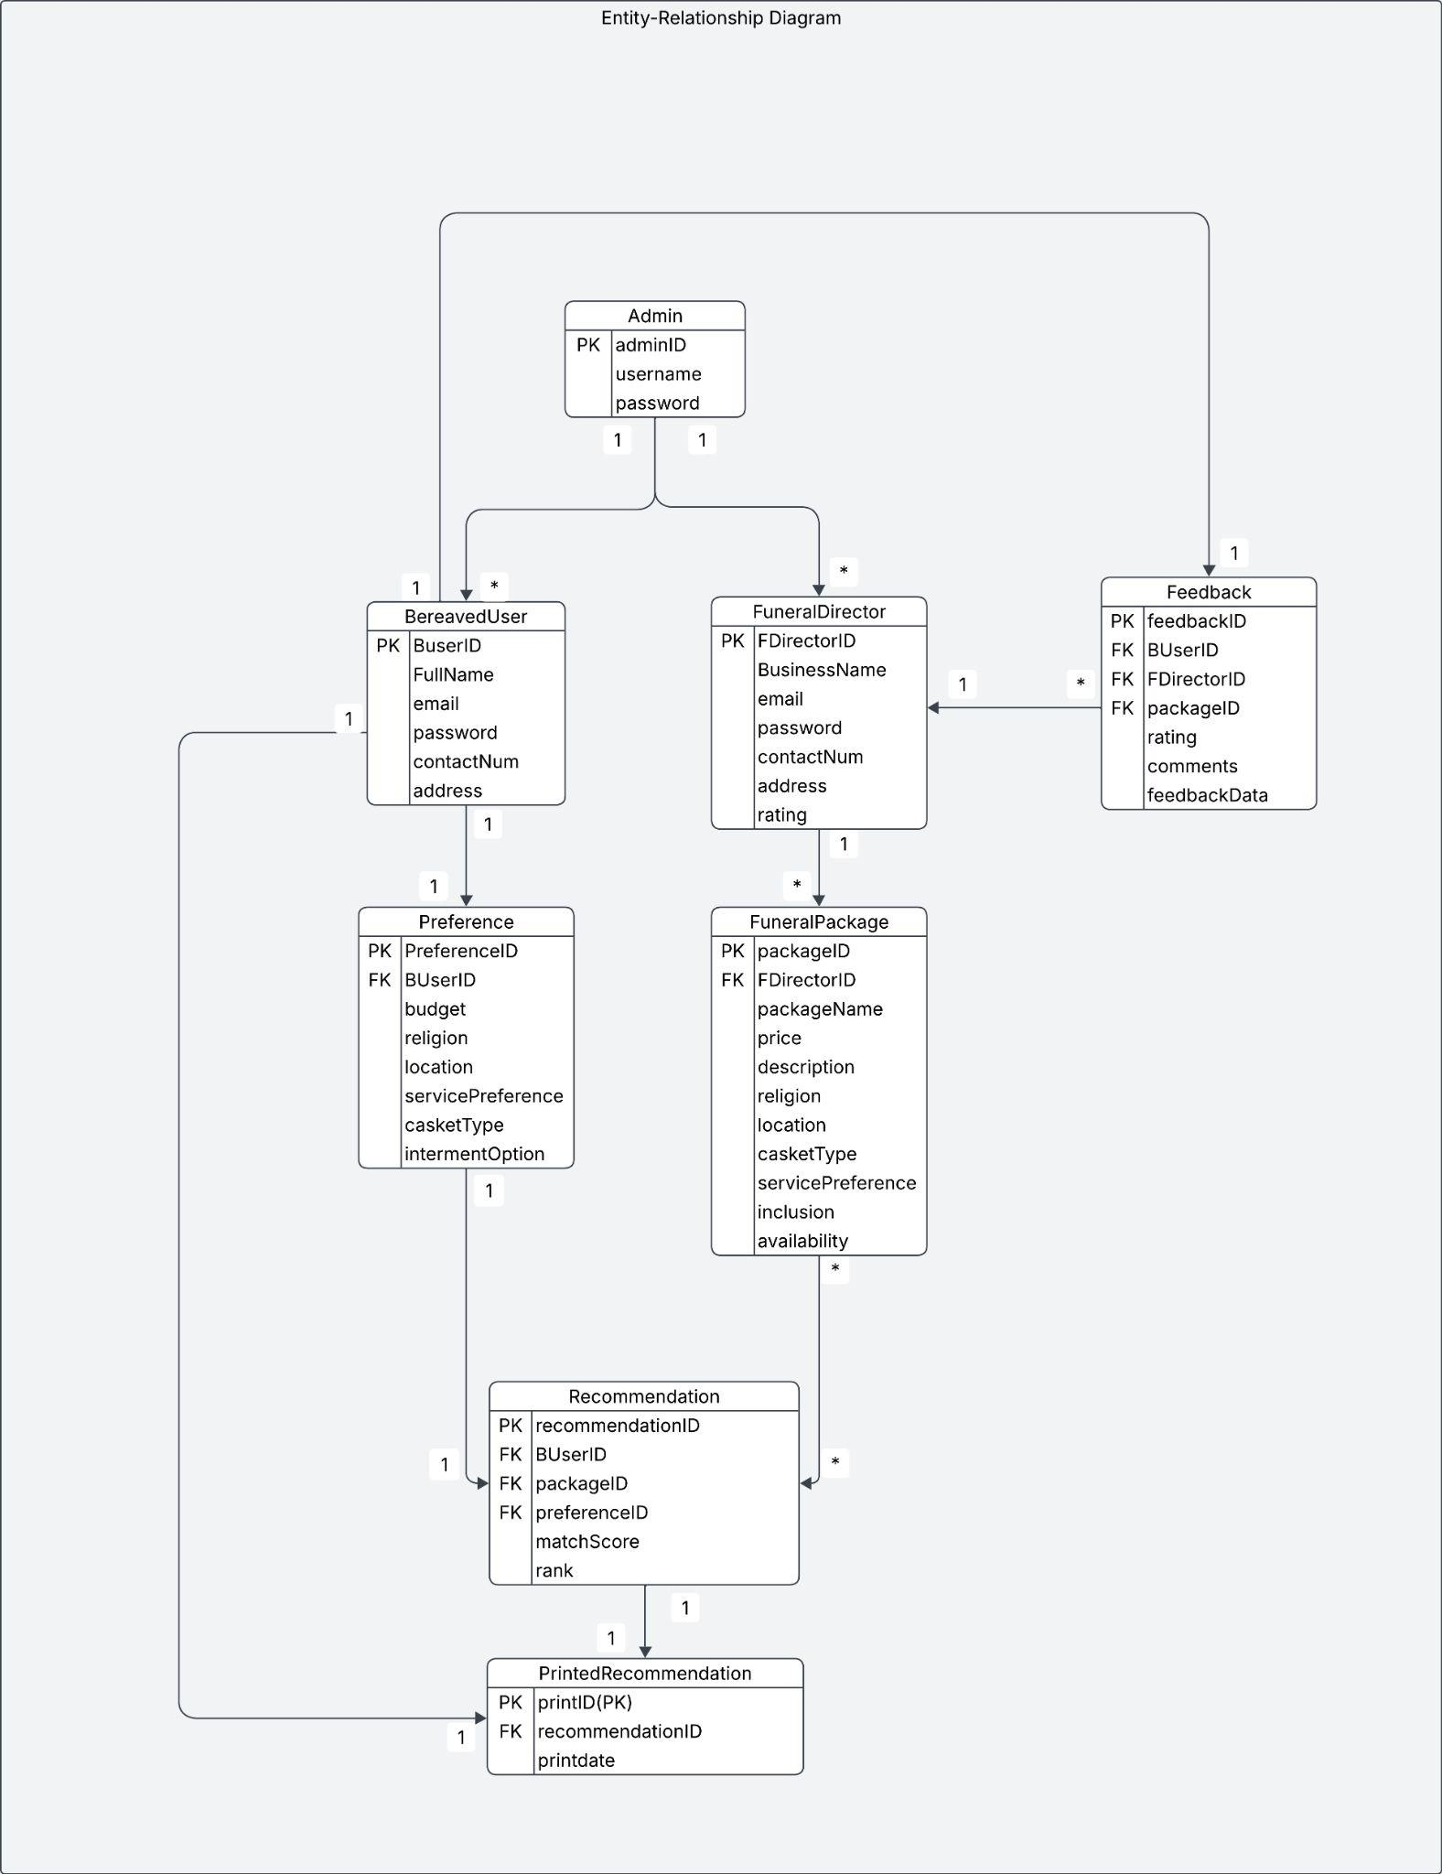
Figure 18: Entity-Relationship Diagram (ERD)
Figure 18 illustrates the Entity-Relationship Diagram (ERD) of the proposed Funeral Preference Recommender System (FPRS). The diagram presents the logical database structure of the system by identifying the major entities, their attributes, primary keys, foreign keys, and the relationships among them. It serves as the foundation for organizing and storing the information required to support the recommendation process. Through this database design, the system ensures that user preferences, funeral package information, recommendations, and feedback are properly linked, allowing data to be managed efficiently while maintaining consistency throughout the application. The BereavedUser entity stores the personal information of individuals using the system, including their account credentials and contact details. Each bereaved user is associated with a corresponding Preference record that contains information such as budget, religion, location, service preference, casket type, and interment option. These preference details provide the necessary inputs for the recommendation process, allowing the system to understand the specific needs of each user before generating suitable funeral package suggestions. Separating user information from preference data also improves the organization of the database by allowing preference records to be managed independently from user accounts. On the service provider side, the FuneralDirector entity stores the information of registered funeral providers, while the FuneralPackage entity contains the funeral packages they offer. Each funeral director may manage multiple funeral packages, with every package containing important details such as its name, price, description, religious compatibility, location, inclusions, casket type, service preference, and availability. Organizing package information in a separate entity allows funeral directors to update their services without affecting user records and ensures that the recommendation process always evaluates current package information. The Recommendation entity records the results generated after the system compares a user's preferences with the available funeral packages. Each recommendation stores the selected user, the matched package, the preference profile used during evaluation, the calculated matching score, and the ranking of the recommended package. This entity serves as the bridge between the user's preferences and the available funeral packages, making it possible for the system to generate personalized recommendations based on the implemented hybrid recommendation approach. Once a recommendation has been selected, the PrintedRecommendation entity stores information related to the printable recommendation document, allowing users to print the recommended package and present it to the funeral provider during their walk-in transaction. To support continuous service improvement, the system also includes the Feedback entity, which stores the ratings and comments submitted by bereaved users after completing their transactions with the funeral provider. Each feedback record is linked to the corresponding user, funeral package, and funeral director, making it possible to identify which service was evaluated. The collected feedback provides valuable information that funeral directors can review to improve their services while also serving as additional reference data for future recommendation processes.

Requirement Analysis
The minimum hardware and software requirements used in the development of the system are presented.
Table 1 shows the minimum hardware requirements of the system.
Table 1
Hardware Specification

Hardware Components | Minimum Requirements
Processor (CPU) | 12th Gen Intel® Core ™ i3-1215U (1.20Ghz)
Memory (RAM) | 8 GB
Storage | 238 GB
Graphics Processor (GPU) | Intel ® UHD Graphics
Input Devices | Mouse and Keyboard

The system requires a 12th Generation Intel® Core™ i3-1215U (1.20 GHz) or higher to ensure the stable computational performance necessary for executing hybrid recommendation algorithms and managing real-time data synchronization. It is equipped with 8 GB of RAM to facilitate seamless multitasking between the PHP backend operations and the responsive frontend, ensuring zero latency during user interactions.
For storage, the system utilizes a 256 GB SSD (NVMe preferred) to provide rapid data access, high reliability, and efficient handling of the system's database and assets. The Intel® UHD Graphics are sufficient for rendering the clean, professional visual elements of the interface and ensuring high-quality display across both mobile and desktop platforms.
For input, a mouse and keyboard are necessary for administrative data management and system configuration, while a touchscreen interface serves as the primary input for mobile users. An HD monitor or high-resolution mobile display is required as the output device to present personalized funeral recommendations and booking tracking with clarity and aesthetic precision.
Table 2 shows the minimum software requirements for the system.
Table 2
Software Specification
Software Components | Minimum Requirements
Operating System | Microsoft Windows 10 or higher
IDE | Visual Studio Code

Programming Language | PHP
Database | Firebase and MySQL
The selection of software components is strategically chosen to ensure the reliability, real-time responsiveness, and security of the FPRS website. The use of Microsoft Windows 10 or Higher provides a robust environment compatible with modern development tools and hardware drivers. Visual Studio Code is selected as the primary Integrated Development Environment (IDE) for its lightweight nature and extensive plugin ecosystem, which streamlines the coding of complex recommendation algorithms.
The core of the system is built on PHP, which is suited for its "Hybrid Recommendation Logic." For the database, Firebase is utilized instead of traditional local databases to provide real-time data synchronization; and MySQL for relational database to provide accurate recommendation; this is critical for funeral directors and bereaved families who need instant updates on service availability and booking statuses. Finally, the use of Tailwind CSS ensures that the user interface is fully responsive, allowing for a seamless experience across mobile devices and desktop computers, which is essential for users who may be accessing the system during time-sensitive situations.
Table 3 shows the minimum technology stack for the system
Table 3
Technology Stack
Layer | Technology
Backend Framework | PHP
Relational Database | MySQL
Real-time Database | Firebase
Frontend Framework | Tailwind CSS
Intelligence Layer | Hybrid Algorithm
Accessibility | Responsive Design

For Database Management, the system employs a dual-model approach: MySQL is used to maintain structured records of service providers and package attributes, while Firebase is integrated for real-time data handling.
This attributes are crucial for creating a personalized recommendation package. The Frontend is designed using Tailwind CSS, emphasizing a sensitive "grieving UI/UX" that reduces the cognitive load on users during high-stress periods.

Figure 12 illustrates the system architecture.
Figure 12
System Architecture
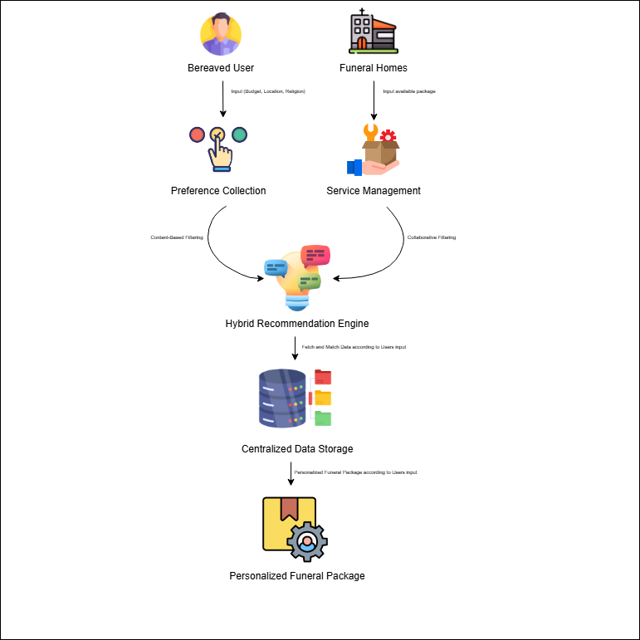
The System Architecture of the Funeral Preference Recommender System (FPRS)

System’s Evaluation
The software was developed following the Agile Development Methodology, allowing for iterative improvements based on continuous feedback. The system’s quality and overall acceptability were evaluated based on the ISO/IEC 25010:2023 Software Quality Model, which ensures the platform meets international standards for functional suitability, performance efficiency, and usability. The assessment was conducted by three (3) distinct groups of evaluators: IT Experts, Funeral Service Providers, and End-Users from the local communities of Guimbal and Miagao. A total of forty (40) evaluators participated in the study: six (6) IT experts to verify the technical framework, four (4) funeral service providers to assess administrative functionality, and thirty (30) end-users to validate the system’s usability.
Table 4 shows the distribution of evaluator participants.
Table 4
Distribution of Evaluator Participants
Group | n | %
- Funeral Service Providers | 4 | 9
- End-Users | 40 | 91
 | N =44 | 100
As presented in Table 4, the system was evaluated by two (2) distinct groups of participants: Funeral Service Providers and End Users, with a total of forty (44) respondents. The Funeral Service Providers, composed of four (4) participants or 9%, evaluated the administrative functionalities and the system's capacity to manage inventory and service coordination accurately.
Meanwhile, the End Users, consisting of thirty (40) participants or 75% of the total, included residents from the local communities of Guimbal and Miagao. They evaluated the system based on their experience using the FPRS website, emphasizing its usability, visual clarity, and the ease of navigating the personalized recommendation process during high-stress situations. The diverse representation of technical experts, service providers, and community members ensured a well-rounded evaluation process. While the IT Experts and service providers provided insights into the system’s technical soundness and operational utility, the community end-users offered meaningful feedback regarding user experience and the platform's effectiveness in reducing information overload during funeral planning.

Table 6 shows the criteria used for evaluation of end users based on ISO/IEC 25010:2023.
Table 6
Criteria Used for Evaluation of End Users Based on ISO/IEC 25010:2023

Characteristics | n
Functional Suitability | 10
Performance Efficiency | 10
Compatibility | 10
Interaction Capability | 10
Reliability | 10
Security | 10

Note. The criteria for the End users’ evaluation are based on ISO/IEC 25010:2023, adapted from Digital Realm: Navigating Puluy-an's Virtual Art Exhibition by Frava et al. (2026).

Table 6 summarizes the evaluation criteria used by the thirty (30) end-user participants in assessing the system in accordance with the ISO/IEC 25010:2023 Software Quality Model. The evaluation covered six core quality characteristics: functional suitability, performance
efficiency, compatibility, interaction capability, reliability, and security. Each characteristic was assessed by all thirty respondents (N = 30), ensuring uniform representation across all dimensions of the system’s quality assessment. (Frava et al. 2026)

Table 7 shows the criteria used for evaluation of funeral directors based on ISO/IEC 25010:2023.
Table 7
Criteria Used for Evaluation of Funeral Directors Based on ISO/IEC 25010:2023

Characteristics | n
Functional Suitability | 10
Performance Efficiency | 10
Compatibility | 10
Interaction Capability | 10
Reliability | 10
Security | 10
Note. The criteria for the Funeral Directors’ evaluation are based on ISO/IEC 25010:2023, adapted from Digital Realm: Navigating Puluy-an's Virtual Art Exhibition by Frava et al. (2026).
Table 7 summarizes the evaluation criteria used by the four (4) funeral directors in assessing the system in accordance with the ISO/IEC 25010:2023 Software Quality Model. The evaluation covered six core quality characteristics: functional suitability, performance efficiency, compatibility, interaction capability, reliability, and security. Each characteristic was assessed by all four respondents (N = 4), ensuring uniform representation across all dimensions of the system’s quality assessment. (Frava et al. 2026)

Table 8 shows the five (5) point Likert Scale as the basis for evaluating the system.

Table 8
Likert Scale Rating
Weight | Parameter Limits
4.50 – 5.00 | Excellent
3.50 – 4.49 | Very Satisfactory
2.50 – 3.49 | Satisfactory
1.50 – 2.49 | Good
1.00 – 1.49 | Poor
Security | 10
Note. This Likert Scale is adapted from Digital Realm: Navigating Puluy-an's Virtual Art Exhibition by Frava et al. (2026).
Table 8 presents the Likert Scale Rating used to evaluate the system, serving as a standardized basis for interpreting the mean responses of the evaluators. The scale ranges from 1.00 to 5.00, with descriptive equivalents indicating the level of quality and user satisfaction. Ratings from 4.50–5.00 are interpreted as Excellent, 3.50–4.49 as Very Satisfactory, 2.50–3.49 as Satisfactory, 1.50–2.49 as Good, and 1.00–1.49 as Poor. This scale provided a consistent and objective means of analyzing feedback from IT Experts, Funeral Service Providers and End Users, allowing the researchers to determine the overall quality, usability, and acceptability of the developed system. (Frava et al. 2026)

References

Ahmad, A. R., Khang, W. C., & Noor. (2025). Understanding Consumer Preferences in the Funeral Service Industry: Insights from the Johor Bahru Market. JBS Nexus, 2(1), 39–46. https://publisher.uthm.edu.my/ojs/index.php/jbsnexus/article/view/21156
and, T. (2025). RECOMMENDER SYSTEMS IN E-LEARNING: TRENDS, CHALLENGES, AND FUTURE DIRECTIONS. Zenodo. https://doi.org/10.5281/zenodo.17190790
Bingaman, K. A. (2023). Religion in the Digital Age: An Irreversible Process. Religions, 14(1), 108. https://doi.org/10.3390/rel14010108
Chan, W. C. H., Wong, R., & Li, C. (2026). A home-based palliative care service in Hong Kong: supporting patients and family caregivers’ provision of end-of-life care. Asia Pacific Journal of Social Work and Development, 1–17. https://doi.org/10.1080/29949769.2026.2618660
Clair, C., Taylor, J., & Tobin, K. (2025). The Social-Medical Network: Integration of Personal and Professional Healthcare Networks. Innovation in Aging, 9(Supplement_2). https://doi.org/10.1093/geroni/igaf122.572
Coelho, A., Albuquerque, S., & Neto, D. D. (2025). Bereavement support guidelines for caregivers in palliative care: a scoping review. Frontiers in Psychology,
16. https://doi.org/10.3389/fpsyg.2025.1541783
Holland-Hart, D., Rogerson, J., & Edwards, M. (2026). Death literacy: A document analysis review of the United Kingdom’s four countries’ policies. Palliative Care and Social Practice, 20. https://doi.org/10.1177/26323524251408431
Karpe, P. P., Anushka Pandit Sonawane, Bhavesh Gautam Dhivare, Vrushabh Umesh Raundal, & Wagh, V. (2026). FUNERAL MANAGEMENT. INTERNATIONAL JOURNAL of ENGINEERING DEVELOPMENT and RESEARCH, 14(1), 10–1310–13. https://rjwave.org/ijedr/viewpaperforall.php?paper=IJEDR2601612
Kenneth, M., & Namoco, S. O. (2025). Virtual Mourning in a Collectivist Culture: A Hermeneutic Phenomenology of Filipino Grief and Continuing Bonds on Facebook. OMEGA--Journal of Death and Dying. https://doi.org/10.1177/00302228251363017
Kim, S., Lee, S., Biswas, D., Shahnawaj, M., Mahmood Kyoom, N., & Bhardwaj, P. (2025). PERSONALIZATION AND RECOMMENDATION SYSTEMS: LEVERAGING MACHINE LEARNING ALGORITHMS TO OFFER PERSONALIZED PRODUCT RECOMMENDATIONS AND CONTENT TO CUSTOMERS BASED ON THEIR BEHAVIOR, PREFERENCES AND PURCHASING HISTORY. International Journal of Grid Computing & Applications, 16(2), 1–4. https://doi.org/10.5121/ijgca.2025.16201
Kondraguntla, B., & Kumaran, M. S. (2026). Artificial Intelligence and Machine Learning in Marketing and Service Ecosystems: A Systematic Review and Taxonomy of Applications and Capabilities. ITM Web of Conferences, 85, 02011. https://doi.org/10.1051/itmconf/20268502011
MacNeil, A., Findlay, B., Bimman, R., Hocking, T., Barclay, T., & Ho, J. (2021). Exploring the Use of Virtual Funerals during the COVID-19 Pandemic: A Scoping Review. OMEGA - Journal of Death and Dying, 88(2), 003022282110452. https://doi.org/10.1177/00302228211045288
Makararpong, D., Boonprasop, C., & Jantarat, J. (2024). Intention to Use Online Platform and Application for Funeral Comprehensive Services for Deceased Relatives via Smartphone in Thailand. International Journal of E-Services and Mobile Applications, 16(1), 1–17. https://doi.org/10.4018/ijesma.358107
Nayfeh, A., Conn, L. G., Dale, C., Kratina, S., Hales, B., Das Gupta, T., Chakraborty, A., Taggar, R., & Fowler, R. (2022). The effect of end-of-life decision-making tools on patient and family-related outcomes of care among ethnocultural minorities: A systematic review. PLOS ONE, 17(8), e0272436. https://doi.org/10.1371/journal.pone.0272436
Paiva, B. S. R., Lourenço, B. M., Prata, H. M., Valentino, T. C. de O., Oliveira, M. A. de, Santos Neto, M. F. dos, Bruera, E., & Paiva, C. E. (2023). Burial or cremation? Factors associated with preferences among patients with cancer in Brazil: a cross-sectional study. Sao Paulo Medical Journal, 141(6). https://doi.org/10.1590/1516-3180.2022.0441.r1.13022023
Shimul, Md. M. H., Dowel, I. J., Roy, P., Sufian, A., Ahmed, T. R., Majumder, D., Hossain, Md. K., Khandker, S., Khan, S., & Khan, H. T. A. (2025). Choices and challenges in end-of-life care and decision-making: a nationwide cross-sectional study in Bangladesh. BMC Palliative Care, 24(1). https://doi.org/10.1186/s12904-025-01926-9
Slominski, E. M. (2023). Life of the death system: shifting regimes, evolving practices, and the rise of eco-funerals. Sustainability : Science, Practice and Policy, 19(1). https://doi.org/10.1080/15487733.2023.2243779
Surbakti, F. P. S., Hutahaean, H. A., Inderawati, M. M. W., Madjid, J. M., Sely, L. E., & Yee, Y.-M. (2025). How AI-Driven Personalization Shapes Green Purchasing Behavior Among Youth in Java Island. Sustainability, 17(21), 9600. https://doi.org/10.3390/su17219600
Tu, X. (2025). Optimization Strategy for Personalized Recommendation System Based on Data Analysis. Journal of Computer, Signal, and System Research, 2(6), 32–39. https://doi.org/10.71222/cqnb8e44
Victorio, L. K., Lopez, M. A., Maceda, J. M., Panday, R., & Ocampo, R. (2025). EVERPLAN: A MULTI-PLATFORM FUNERAL ARRANGEMENT AND MANAGEMENT SYSTEM FOR FUNERAL SERVICES. The International Journal of Science, Technology and Engineering, 1(1). https://ijste.psu.edu.ph/index.php/about/article/view/5
VILLAFUERTE, S., Dula, V., Roni Mae Lumberio, Merian Helena Garay, & Alaiza Mea Sioson. (2023). Death Immortalized: The Phenomenology of Social Media Mourning among Filipino Millennials. https://doi.org/10.31124/advance.23653323
Virtual Mourning: How Filipinos Utilize Facebook to Express Grief and Seek Support – A Hermeneutic Phenomenological Study - journal.pafp.org. (2025, December 19). Journal.pafp.org -. https://thepafp.org/journal/abstract/virtual-mourning-how-filipinos-utilize-facebook-to-express-grief-and-seek-support-a-hermeneutic-phenomenological-study/
Ellorza, D. J. C., Santiago, C. J. C., Campilla, A. F., Europa, M. C. Q., & Della, E. M. (2023). Wakes and Burial Practices and Traditions of Ilokano Catholics in Santiago, Ilocos Sur, Philippines. International Journal of Multidisciplinary: Applied Business and Education Research, 4(1), 123-135.

https://doi.org/10.56901/ZMCY5207
Kuznetsova, O. (2021). Digitalization Of Funeral Services. In S. I. Ashmarina, V. V. Mantulenko, M. I. Inozemtsev, & E. L. Sidorenko (Eds.), Global Challenges and Prospects of The Modern Economic Development, vol 106. European Proceedings of Social and Behavioural Sciences (pp. 939-945). European Publisher. https://doi.org/10.15405/epsbs.2021.04.02.112

MONTESA, EDGAR D. (2024) "Grief and loss: Catholic Filipino traditions," International Journal of Faith. Community Nursing: Vol. 10: Iss. 1, Article 6.
https://digitalcommons.wku.edu/ijfcn/vol10/iss1/6
Cabañero, M. K. F., & Guison-Bautista, Ma. T. T. (2025). Virtual mourning: How
Filipinos utilize Facebook to express grief and seek support—A hermeneutic
phenomenological study. OMEGA--Journal of Death and Dying. https://doi.org/10.1177/00302228251331343
Cabañero, M. K. F., & Namoco, S. O. (2025). Virtual mourning in a collectivist culture:
A hermeneutic phenomenology of Filipino grief and continuing bonds on
Facebook. OMEGA--Journal of Death and Dying. https://doi.org/10.1177/00302228251363017
Karpe, P. P., Sonawane, A. P., Dhivare, B. G., Raundal, V. U., & Wagh, V. (2026).
Funeral management. International Journal of Engineering Development and Research, 14(1), 10–13. https://rjwave.org/ijedr/viewpaperforall.php?paper=IJEDR2601612
Kim, S., Lee, S., Biswas, D., Shahnawaj, M., Mahmood Kyoom, N., & Bhardwaj, P.
(2025). Personalization and recommendation systems: Leveraging machine
learning algorithms to offer personalized product recommendations and content to customers based on their behavior, preferences and purchasing history. International Journal of Grid Computing & Applications, 16(2), 1–4. https://doi.org/10.5121/ijgca.2025.16201
Kondraguntla, B., & Kumaran, M. S. (2026). Artificial intelligence and machine learning
in marketing and service ecosystems: A systematic review and taxonomy of applications and capabilities. ITM Web of Conferences, 85, 02011. https://doi.org/10.1051/itmconf/20268502011
Kuznetsova, O. V. (2021). Digitalization of funeral services. In Global Challenges and
Prospects of the Modern Economic Development, Vol. 106. European Proceedings of Social and Behavioural Sciences (pp. 939-945). https://doi.org/10.15405/epsbs.2021.04.02.112
Lawal, T. (2023). Recommender systems in e-learning: Trends, challenges, and future
directions. Zenodo.
https://doi.org/10.5281/zenodo.17190790
Makararpong, D., Boonprasop, C., & Jantarat, J. (2024). Intention to use online platform and application for funeral comprehensive services for deceased relatives via smartphone in Thailand. International Journal of E-Services and Mobile
Applications, 16(1), 1–17.
https://doi.org/10.4018/ijesma.358107
Maulani, N., Farell, G., Hadi, A., Irfan, D., Alzyoud, M., & Nikolaevna, S. R. (2025). Web-based recommendation system for efficient academic supervisor allocation in higher education using the C4.5 decision tree algorithm. Journal of Hypermedia & Technology-Enhanced Learning (J-HyTEL), 3(1), 37–63. https://doi.org/10.58536/j-hytel.165
Montesa, E. D. (2024). Grief and loss: Catholic Filipino traditions. International Journal of Faith Community Nursing, 10(1), Article 6. https://digitalcommons.wku.edu/ijfcn/vol10/iss1/6
Tu, X. (2025). Optimization strategy for personalized recommendation system based on data analysis. Journal of Computer, Signal, and System Research, 2(6), 32–39. https://doi.org/10.71222/cqnb8e44
Victorio, L. K., Lopez, M. A., Maceda, J. M., Panday, R., & Ocampo, R. (2025). EVERPLAN: A multi-platform funeral arrangement and management system for funeral services. The International Journal of Science, Technology and Engineering, 1(1).
https://ijste.psu.edu.ph/index.php/about/article/view/5

